13. Elder’s Words at Yeddonba near Beechworth, Victoria
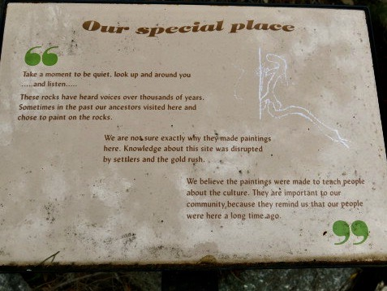
Photo: R. Barz 2018

14. A Man and a Woman at the Basin Track Site
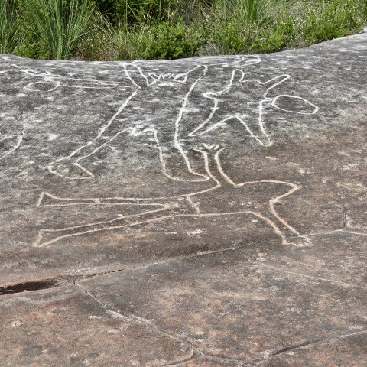
Photo: R. Barz 2018

15. Male and Female Quinkan Figures near Laura, Queensland
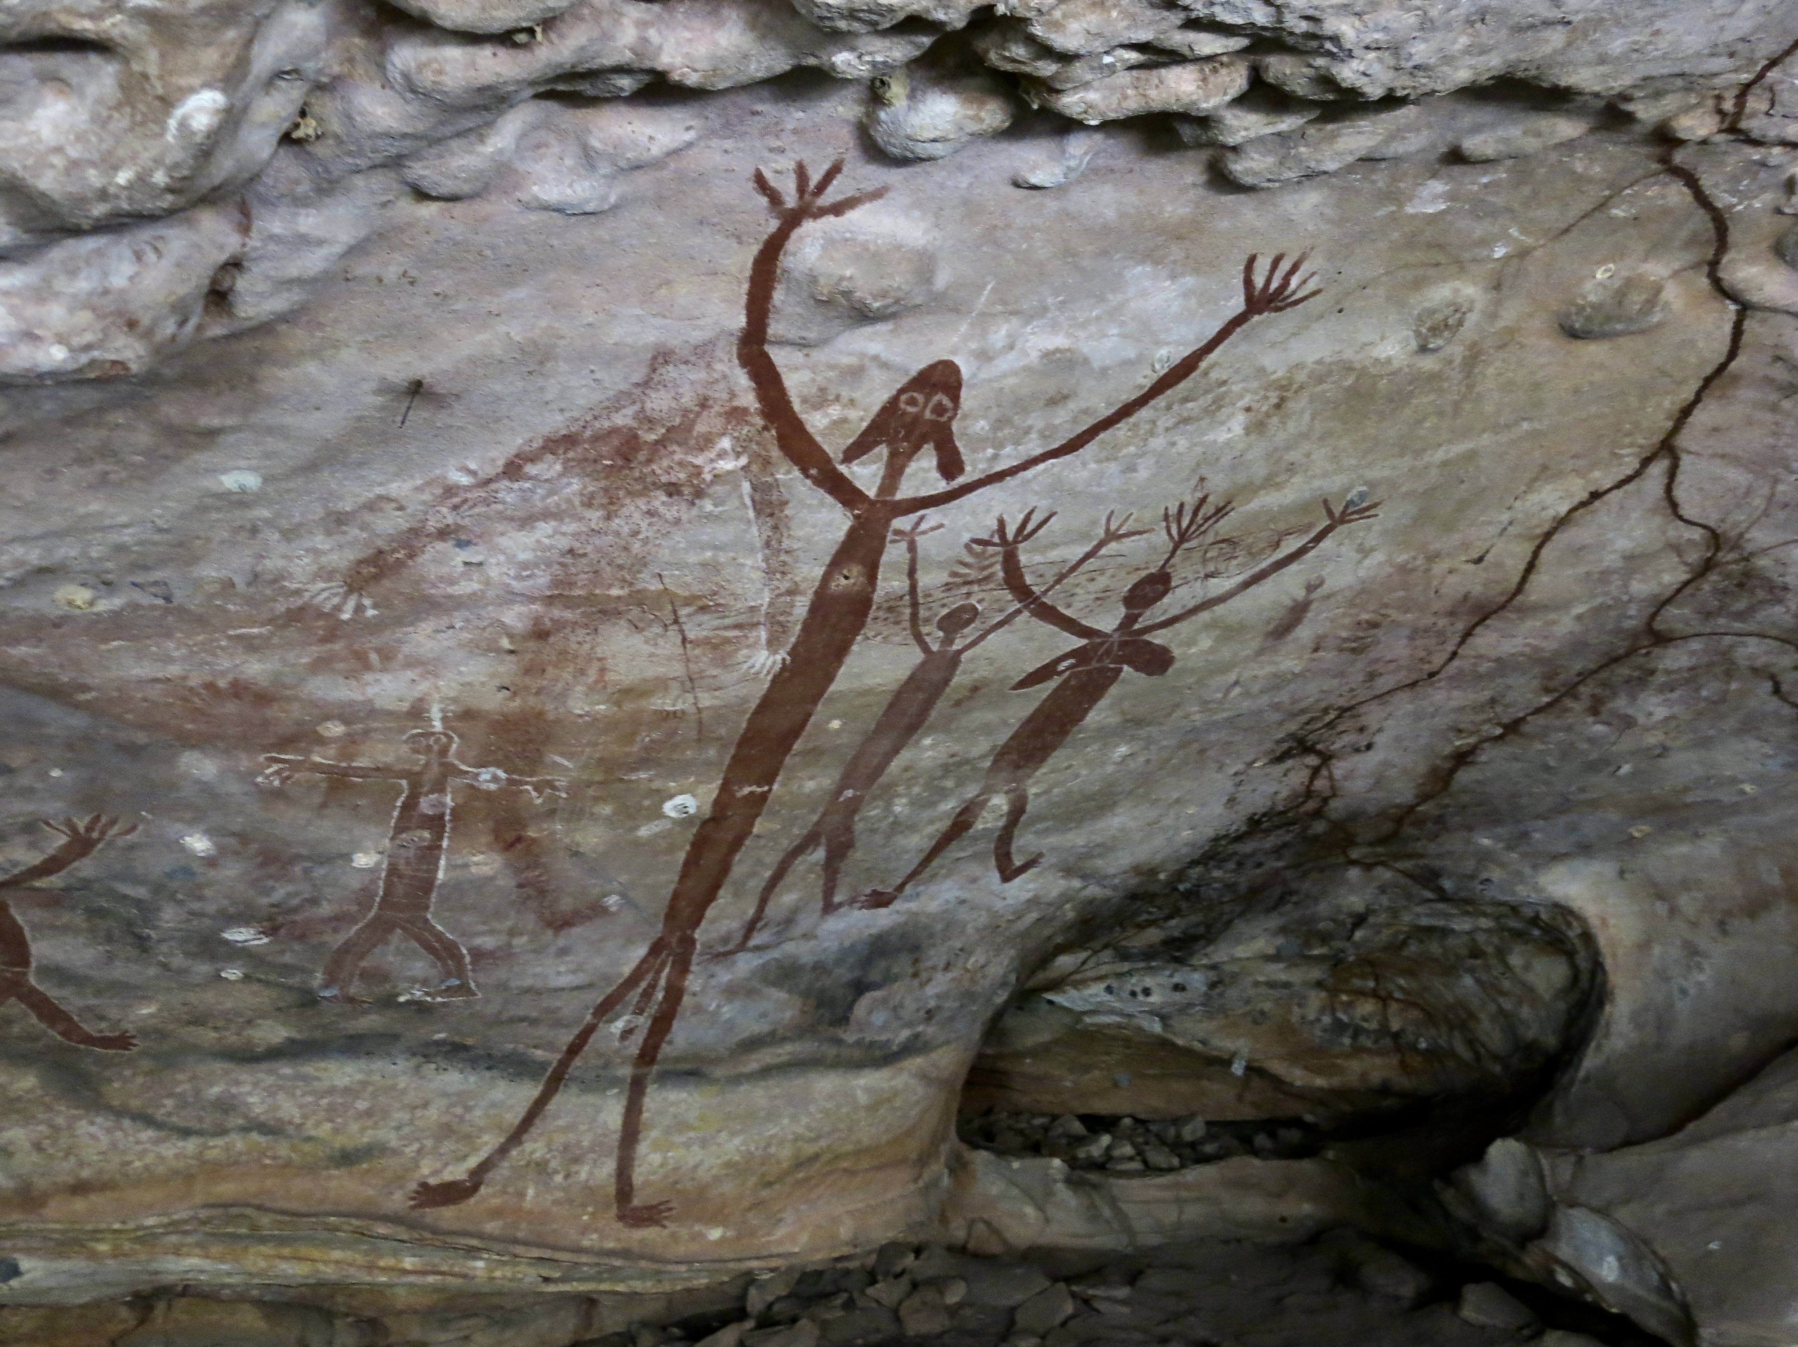
Photo: R. Barz 2019

16. Mrs. Adolphus Sceales with Black Jimmie on Merrang Station (1856)
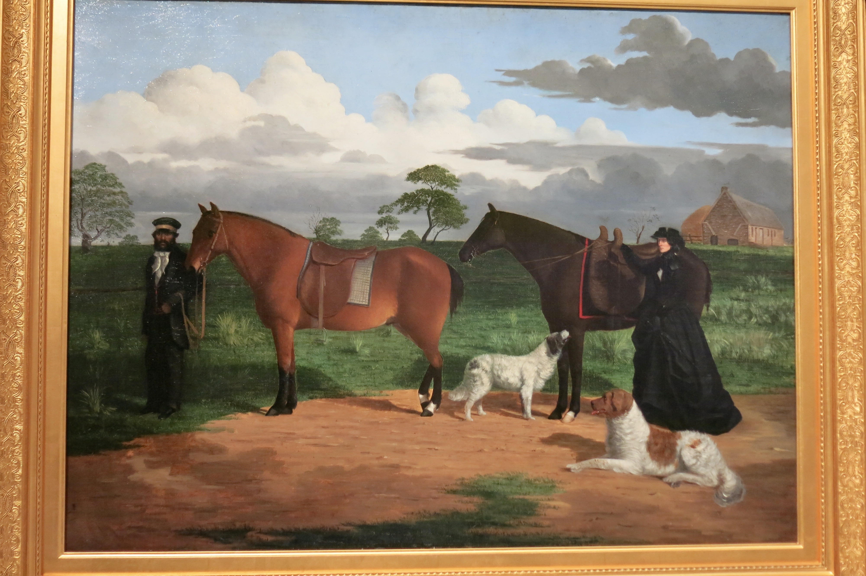
National Gallery of Australia, Canberra

