19. Daramulan on America Bay Track on West Head
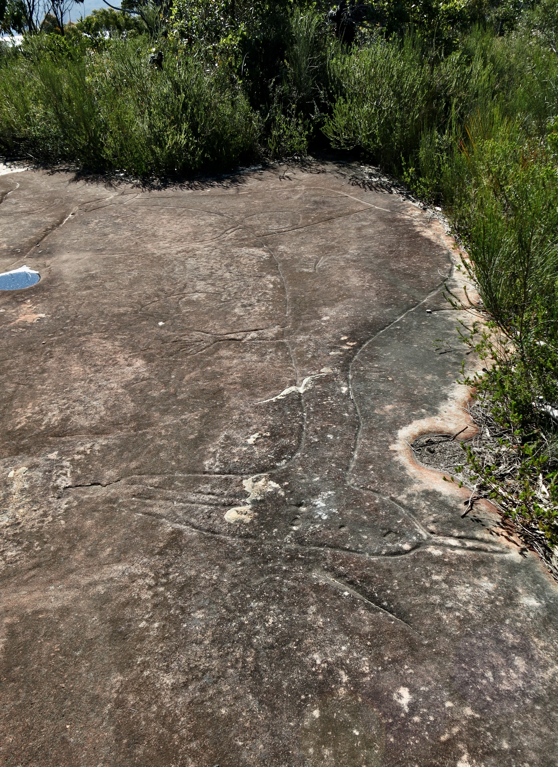
Photo: R. Barz 2019

20. Daramulan on America Bay Track Photo Outlined
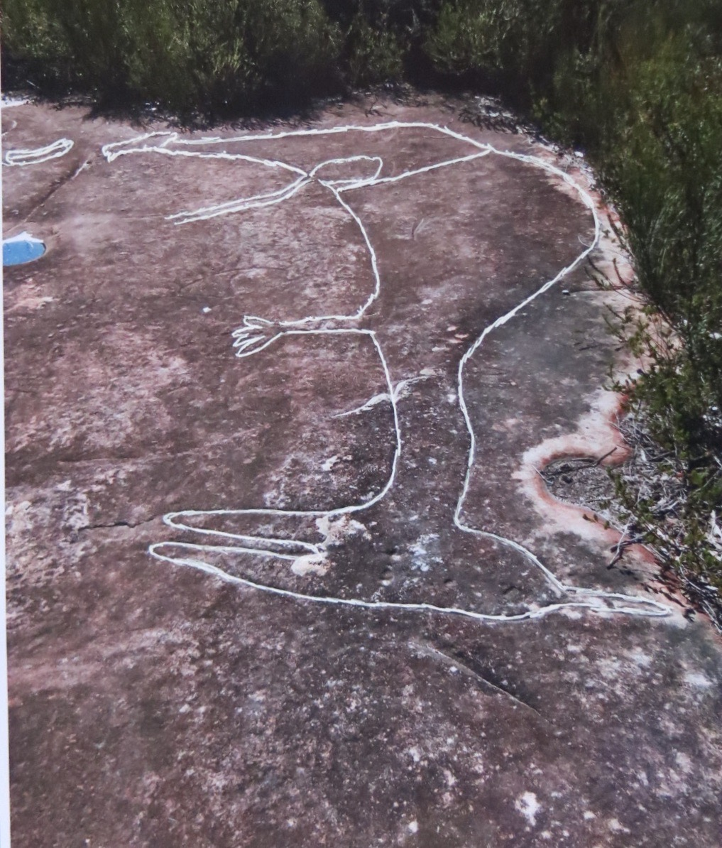
Photo: R. Barz 2019

