Photos

- Mackenzies Point Shark with a Fish in its Stomach
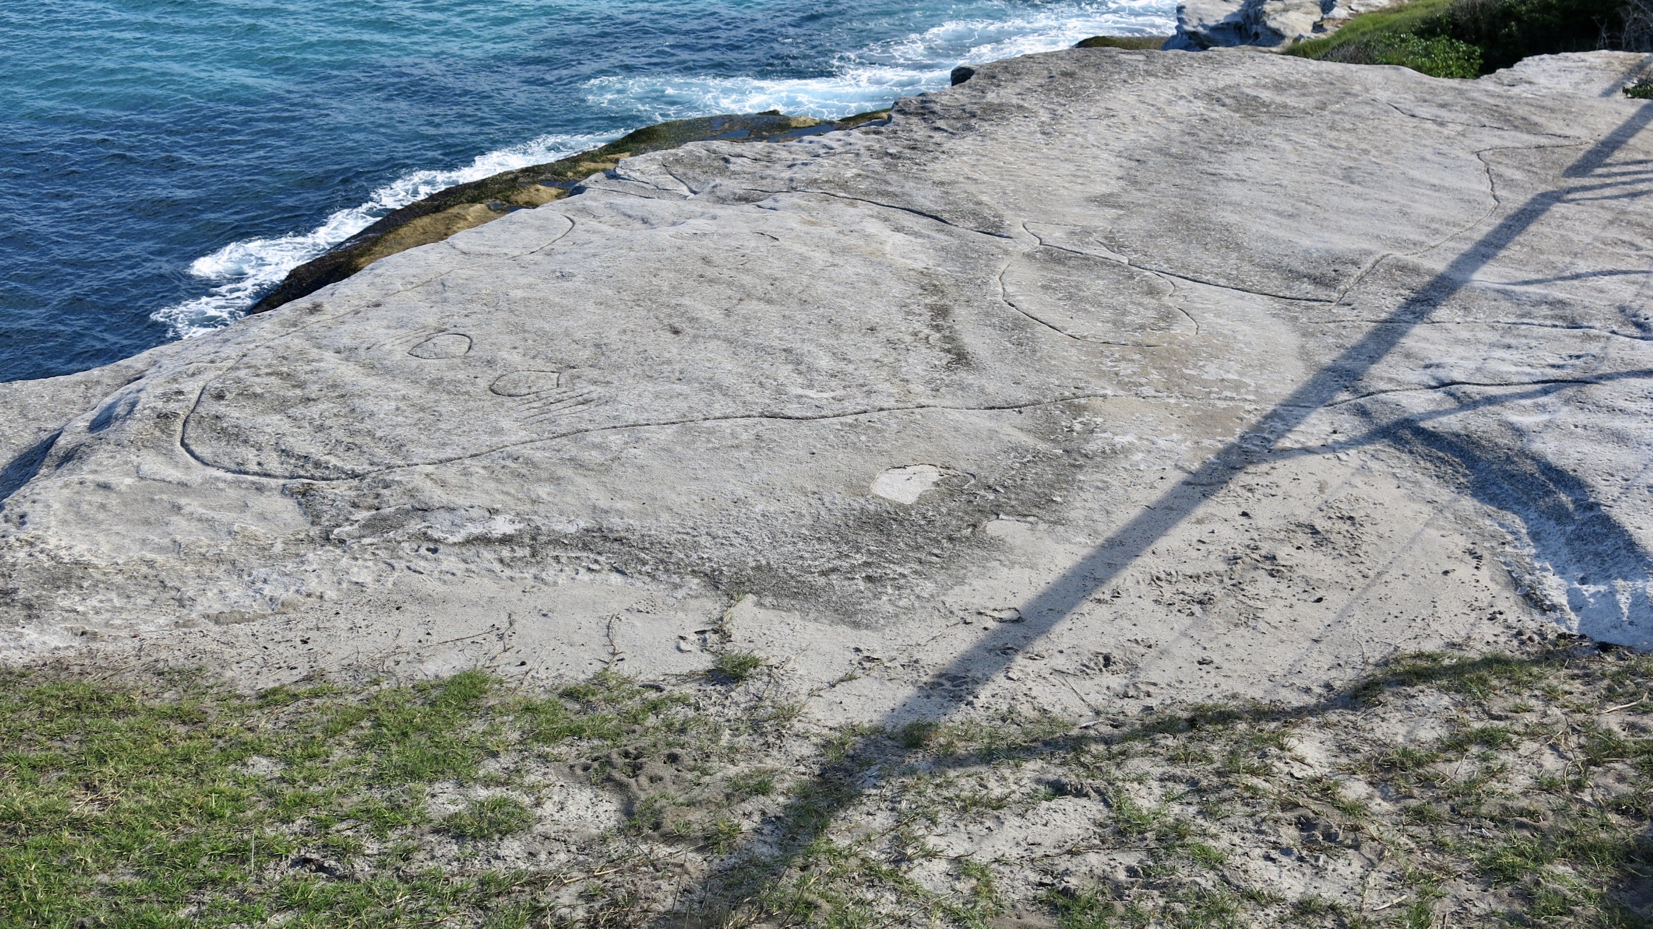
Photo: R. Barz 2018

- Mackenzies Point Shark with a Fish in its Stomach in an Outlined Photo
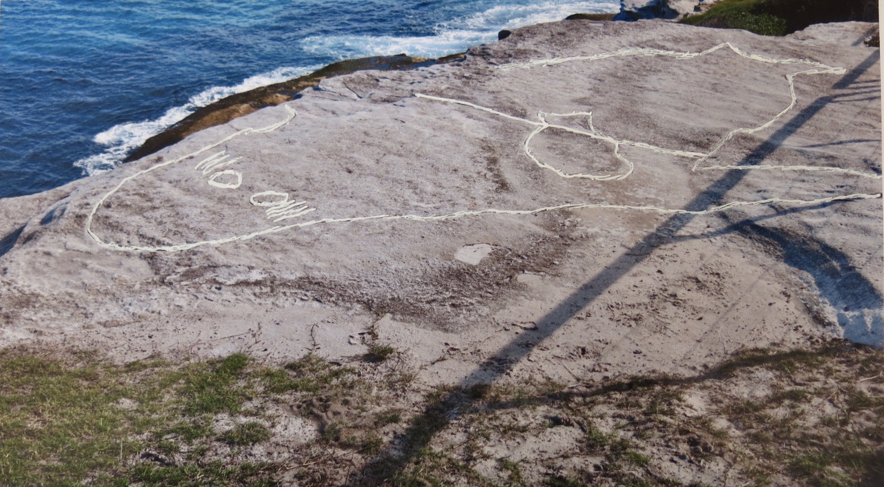
Photo: R. Barz 2018

- Mackenzies Point Walkers Beside the Engraved Shark and Fish
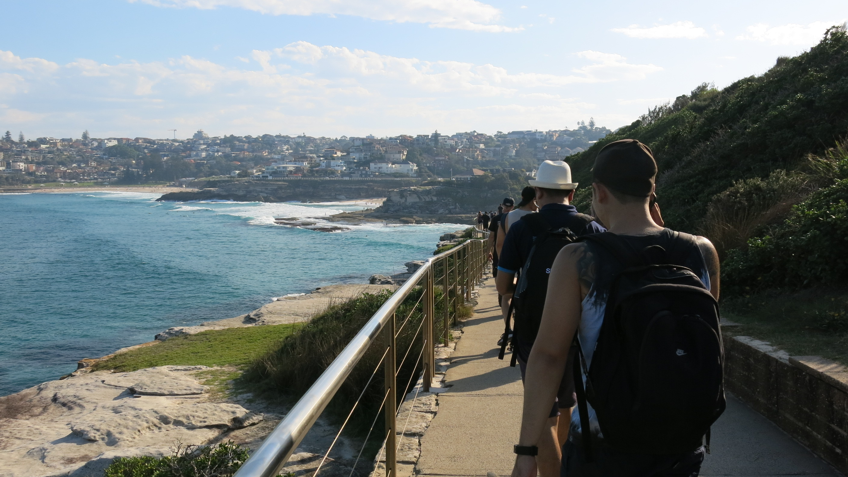
Photo: R. Barz 2018

4. Bull Cave near Campbelltown with Protective Fence
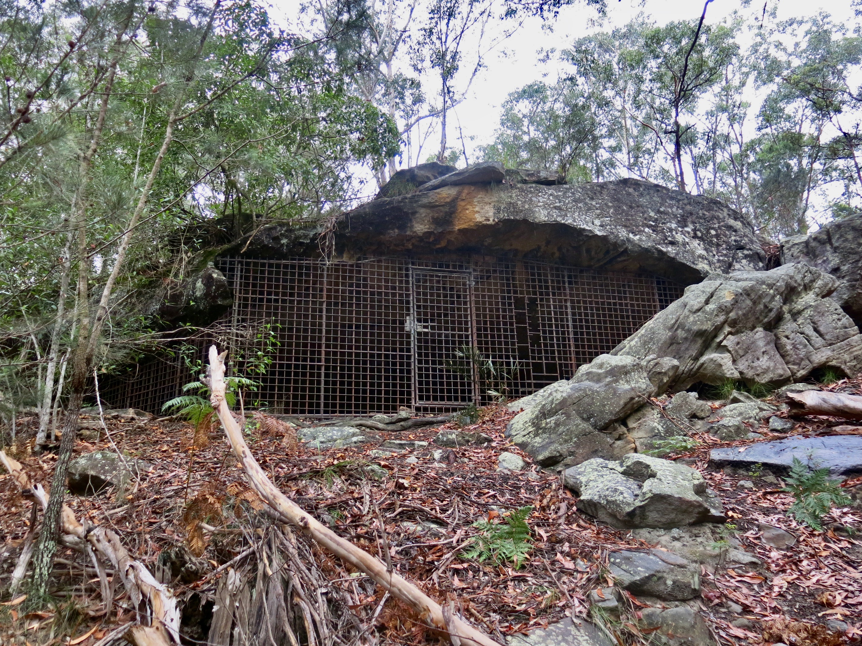
Photo: R. Barz 2017

- Vandalism at the Bull Cave Rock Art Site
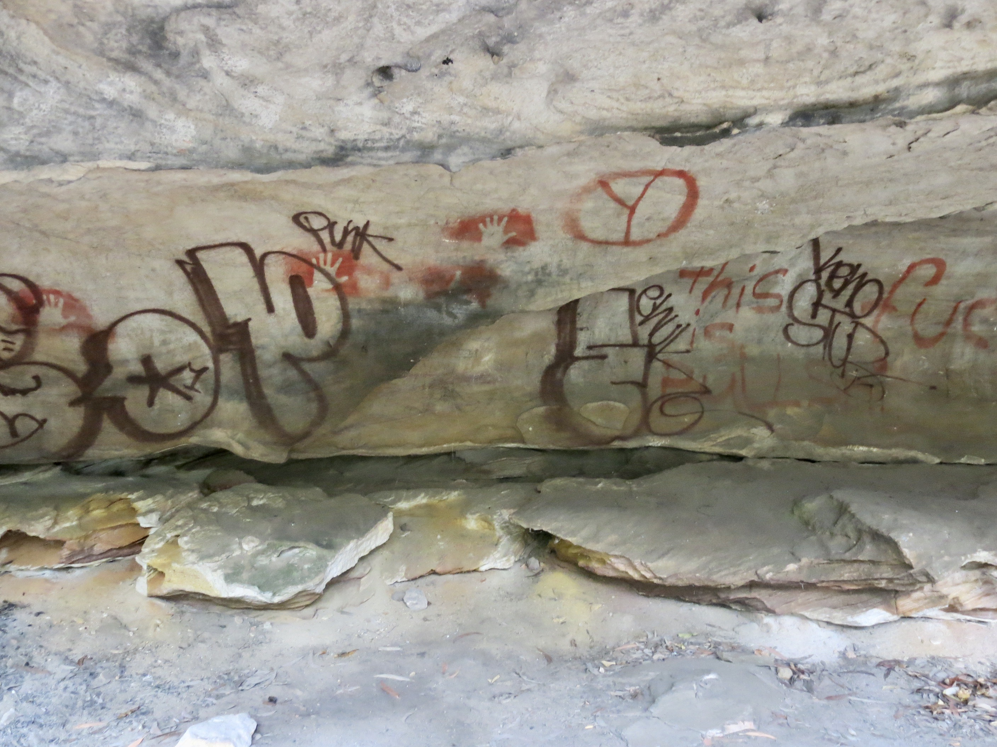
Photo: R. Barz 2017

6. Yankee Hat Mountain, Namadgi National Park
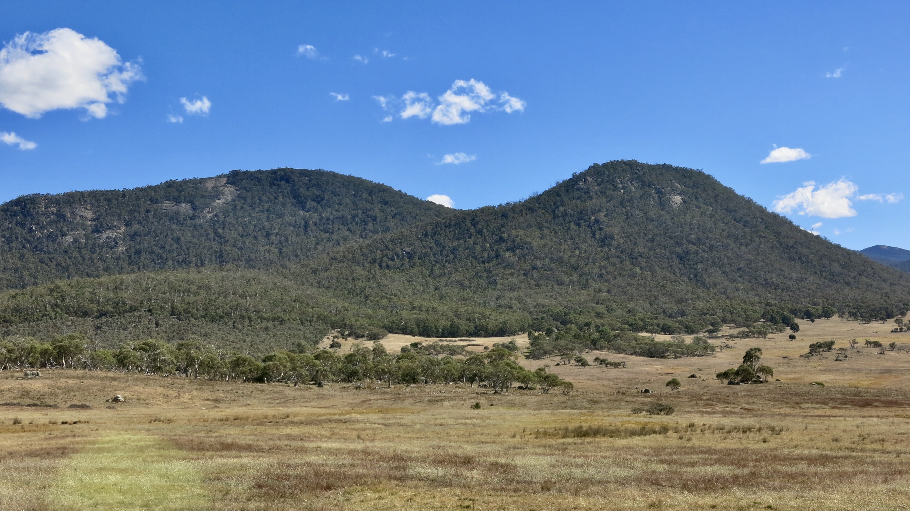
Photo: R. Barz 2017

7. Yankee Hat Rock Painting Site
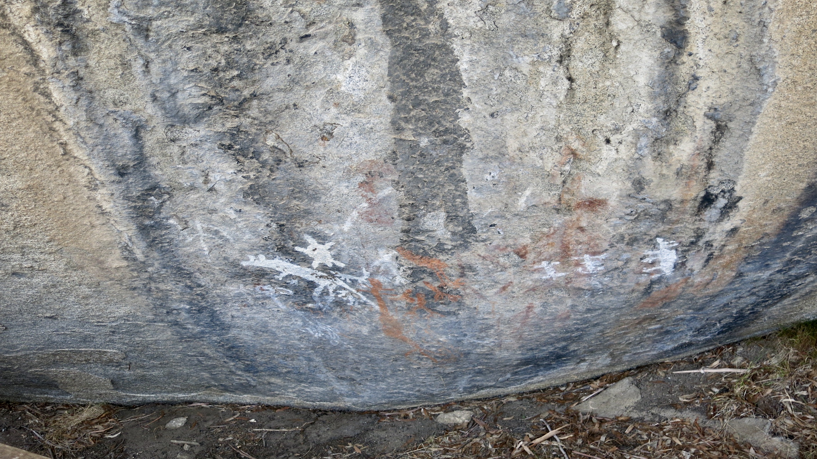
Photo: R. Barz 2017

8. La Perouse Rock Engraving Site
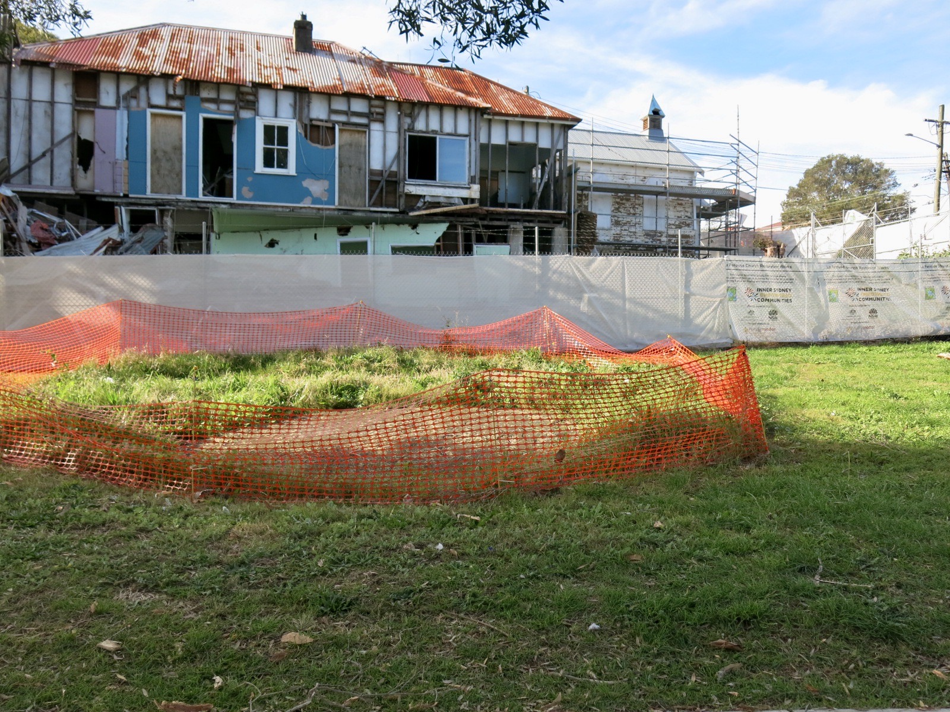
Photo: R. Barz 2020

9. La Perouse Engraving of a Man About To Spear a Kangaroo
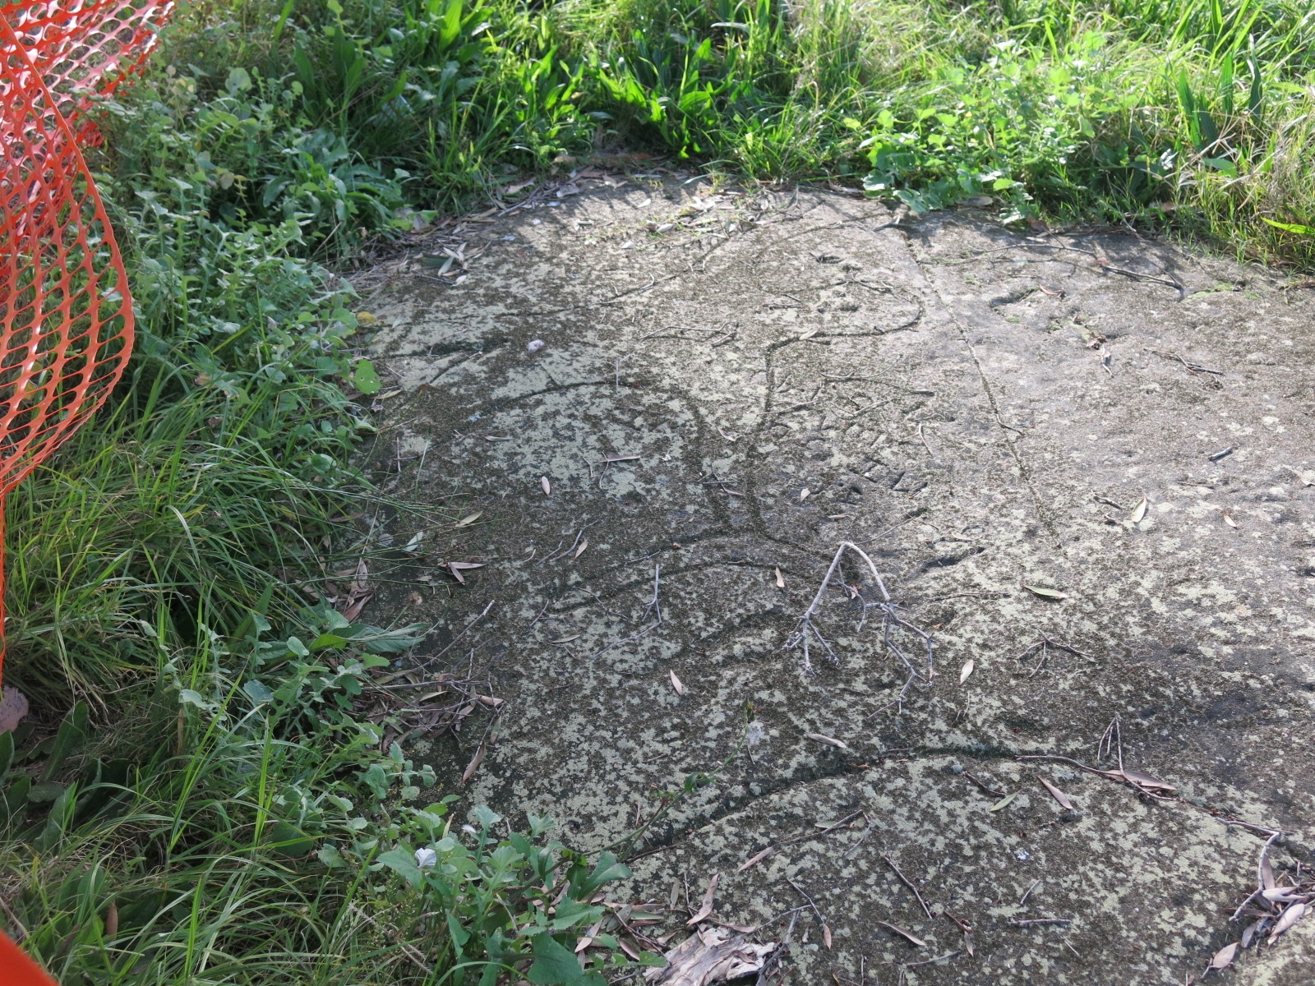
Photo: R. Barz 2020

10. La Perouse Engraving of a Man About To Spear Outlined Photo
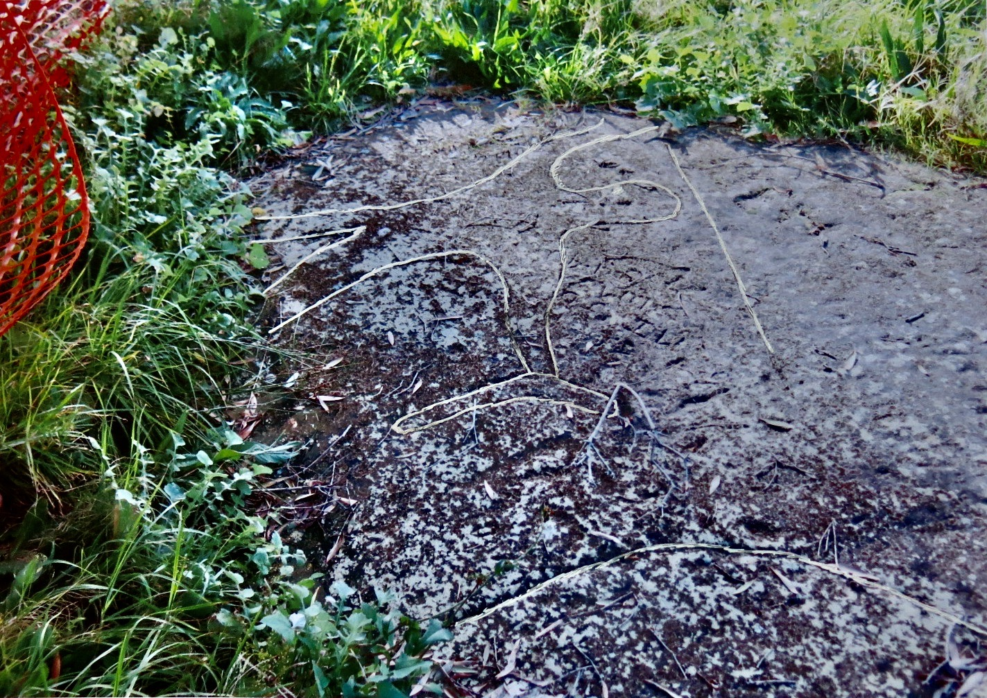
Photo: R. Barz 2020

11. La Perouse Kangaroo About To Be Speared
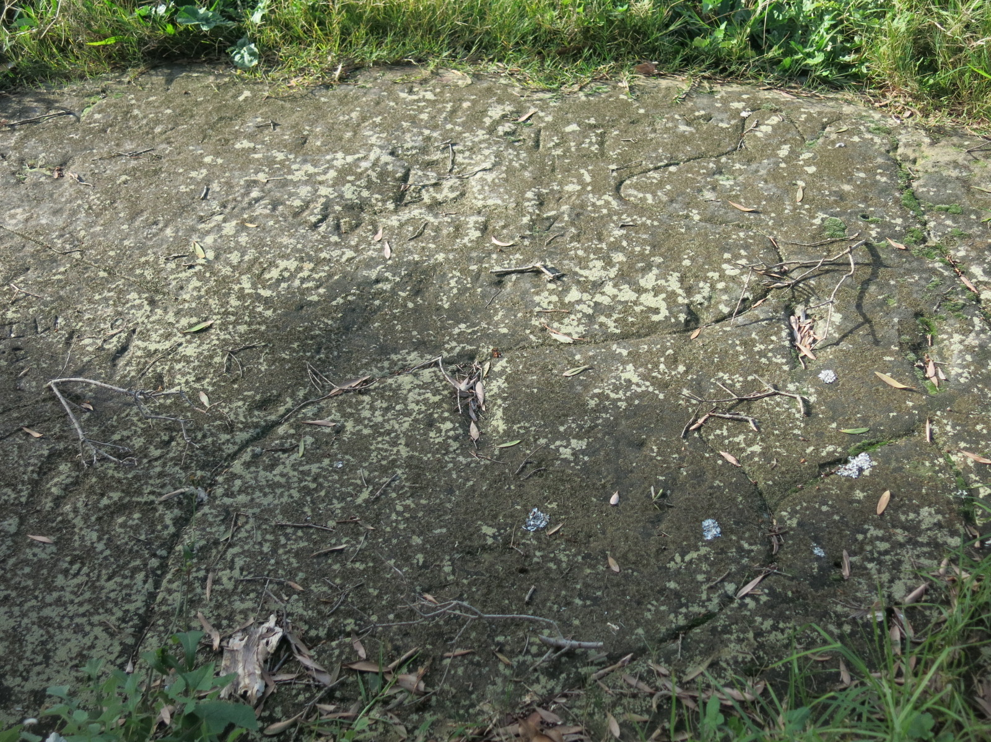
Photo: R. Barz 2020

12. La Perouse Kangaroo About To Be Speared Outlined Photo
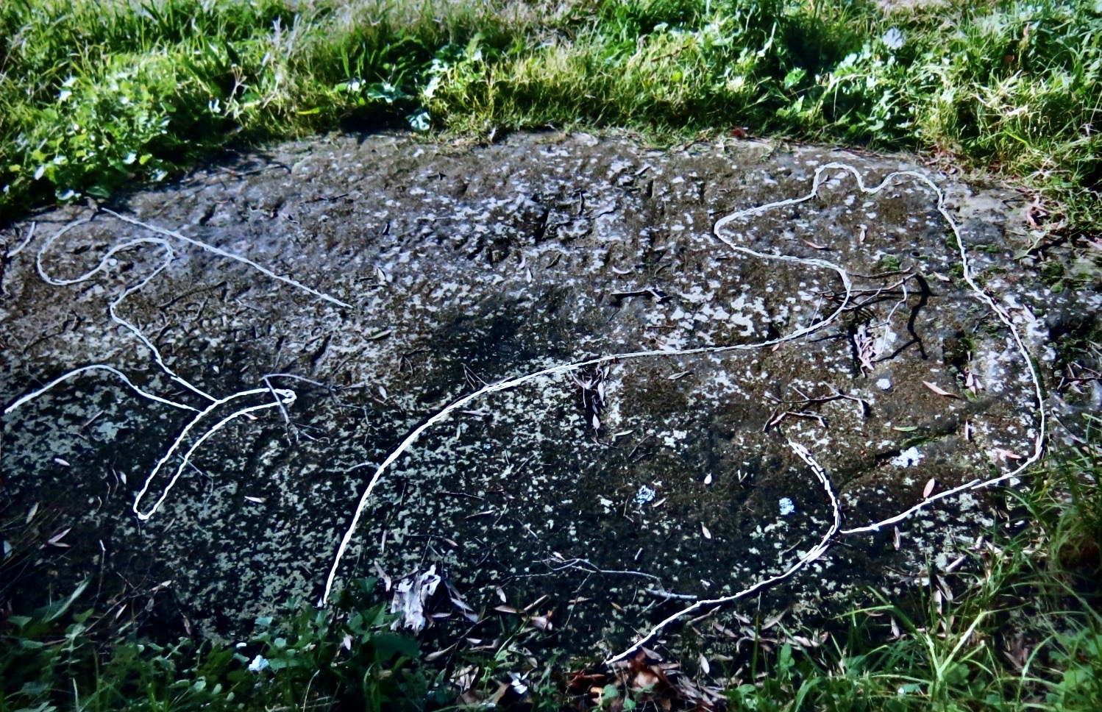
Photo: R. Barz 2020

