thejamesfamily@hotmail.com
www.pcug.org.au/~ajames
www.facebook.com/RobertAndJeanneJames
December 2019

Hello again, from Jeanne and Robert in Watson and families elsewhere,
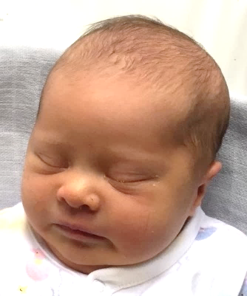
Y
ep, we seem to be maintaining the tradition of announcing a birth each year: This time it’s Chris and Clair’s fourth child (our ninth grand-child): Miss Indira Gabriella James, auspiciously born Melbourne Cup Day 5th November 2019! Mother, father, sisters and bro are all well. Indira couldn’t quite wait another couple of weeks for the “due date”, and was delivered at home with midwives, warm water tub, music and candles. We were all delighted at her safe arrival - a beautiful new daughter / sister / cousin / grand-daughter!

Of course, we have experienced some (minor?) health challenges, we know people who have had serious health challenges, and we’ve attended a few funerals. We still particularly feel the loss of Frank and Joanne last year.
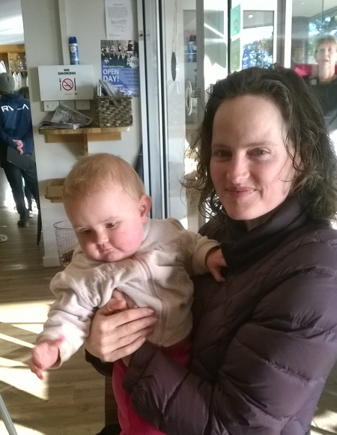
A
drian and Alycia are happy at Phillip Island. We meet Alycia’s parents on occasion at the Mad Cowe Café, sipping chai lattes etc while the bumbling bambini explore the café’s toy resources …
Iona had her first birthday party in October, and is loving life with her doting parents and beautiful bro and sis. She is already making impressive progress with her swimming lessons!

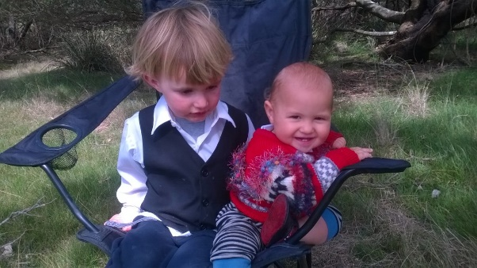
Rohan turns four in February - hard to believe! A lively lad, who loves his little cousin Orlando. He also loves to ride his “new” bike, passed on from Cousin Jack!

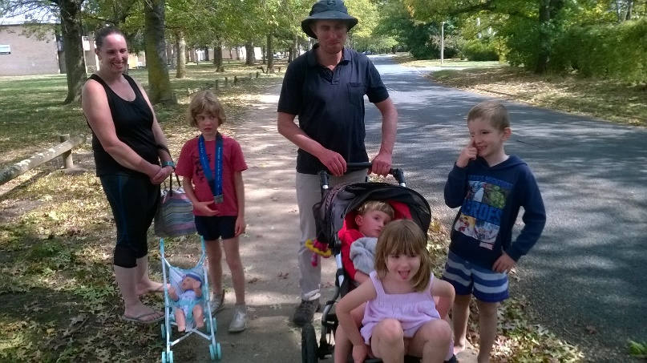
Lily (8) now performs with piano recitals at school concerts. She is a voracious reader, and loves to interact intelligently in any conversation!

Adrian and Karen’s families visited us in Canberra at Easter, and had a great time. Karen and Adrian and Lily did well in the Canberra Running Festival
C
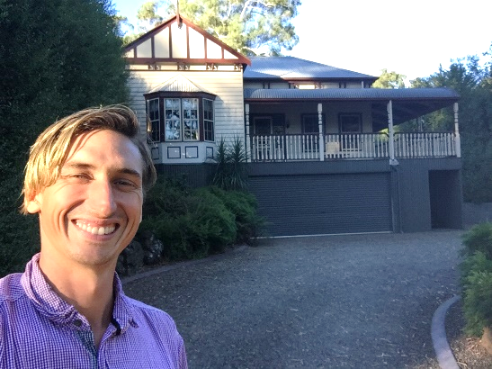
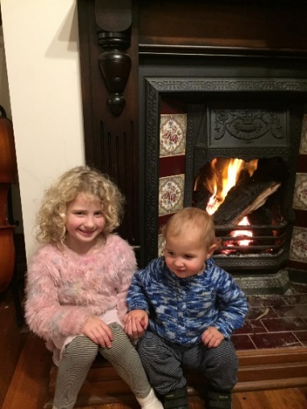
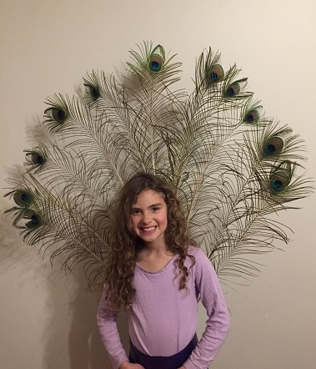
hris and Claire’s “other huge event” (apart from birth of Indira, above) this year was the purchase of their new home at Millgrove, near Warburton, 72 Km north-east of Melbourne (see pics on FB), and close to the Little Yarra Steiner School. This happened just in time, as their rented property in Brighton was about to be demolished. The house has a huge space under, ideal for conducting circus classes and storage of all manner of curious equipment and supplies.

Eloura (8) is remarkably grown-up, a wonderful contributor to housework, family life and sibling-nurture. She enjoys singing, especially to her little sister Indira! Eloura is working hard on her unicycle and other circus and “Funky Monkeys Band” skills.

Jasmin (turning 6 in January) is full of life and love of her new baby sister. Doing well at the Little Yarra Steiner School. She loves circus performance, and would love to pursue dancing classes in 2020.
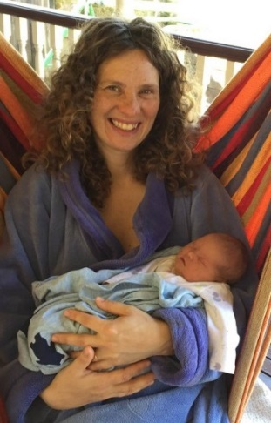
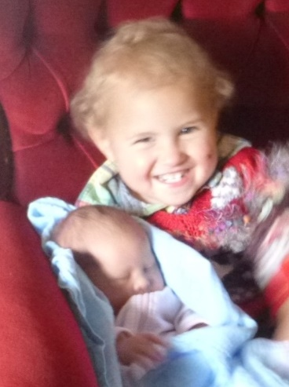
Little Orlando (2) is a bundle of fun, always exploring and learning from watching others. He enjoys his new baby sister, and loves to cuddle her!
And of course, Indira has had a few weeks to come to terms with her part of the world. Just now, it’s enough to eat and (especially) sleep on a regular basis, and continue to grow nicely. She loves to be cuddled by everyone (even grandparents!). We’re not sure how she’ll cope with two big sisters and a big brother!
K
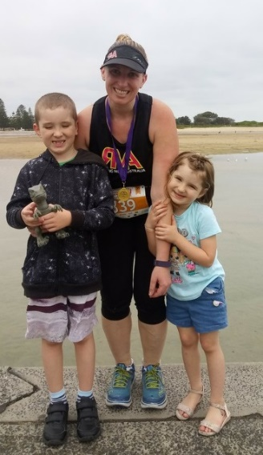
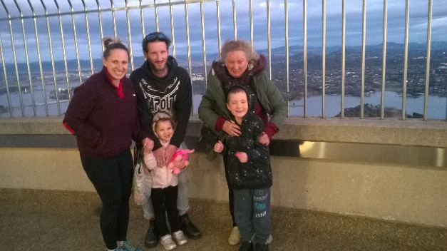
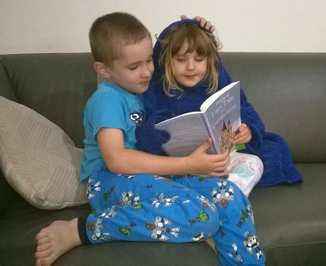
aren and Wade, with Jack and Zoe are enjoying life at Berkeley Vale (north of Gosford). Wade maintains his job as Executive Chef at Normanhurst, and Karen with Sue Mann, organising household support staff. She completed her diploma studies in Business and Human Resources Management, and now seeks alternative employment.
Karen gets out early, running 10km or so before brekky, getting family off to school / childcare. She has become a half-marathon star, with an impressive array of medals!
Jack and Zoe love to read together before bed, and share many interests.
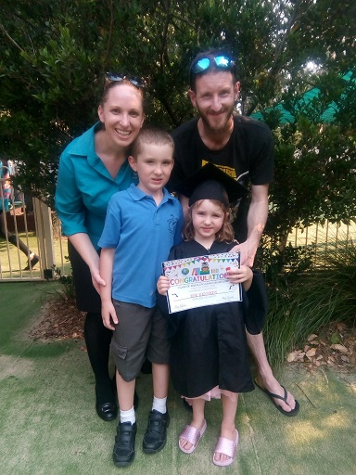
Zoe (turning 5 on 31 December) has proudly graduated from child-care (complete with gown and cap), and anxious to start Kinda at Jack’s school. She has taken to Karate and swimming lessons with gusto, and loves going to the lessons with big bro!

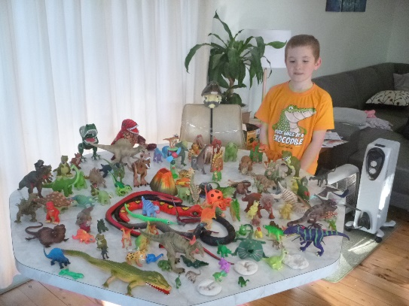
Jack (7) is off to second-grade next year, a proud and careful protector of his “little sister”. A passionate Lego and dinosaur collector, he shares his sister’s commitment to Karate and swimming.
Nana and Pa’s gift of a season ticket to the Reptile Park has been a big hit, providing a most popular holiday activity for the family and their friends.

J
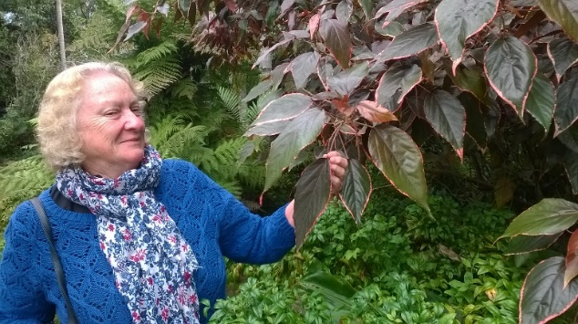
eanne works as a Relief Teacher at various Canberra schools. She still loves the interaction with young students, even those with disabilities and special needs.
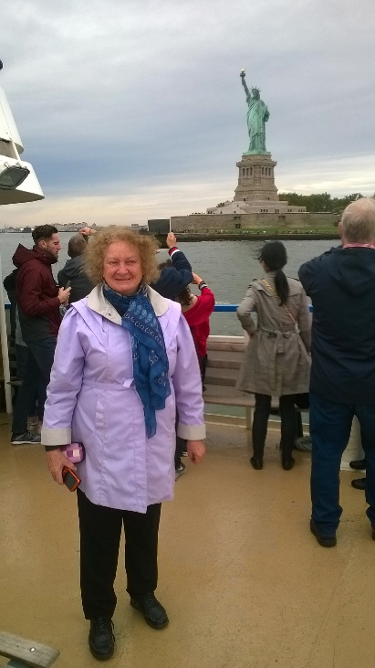
She participates enthusiastically in Indian Dance classes, and has attained Level III in Tai Chi (so we have an elite Marshal Artist in our midst!). She completed an on-line Art Therapy course, and plans to do more work in that area.
As President of the Canberra Jung Society, Jeanne meets lots of “interesting” people. She has been energetic in arranging monthly public meetings with guest speakers, and provides sumptuous suppers for us.
She attended a Literacy Teaching conference in Melbourne, accompanied by Robert, who came along to carry the hotel keys.
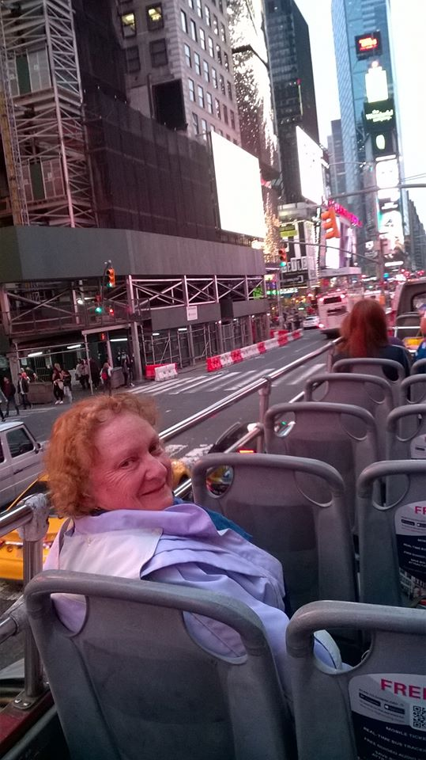
Jeanne is instrumental in the Australian General Semantics Society, and accompanied her hubby to a G.S. event in New York in October.
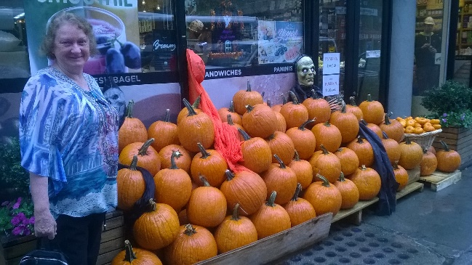
Robert participated in this seven years ago, but was stranded there by Hurricane Sandy. So Jeanne thought that she’d come along this time to keep an eye on him, and fit in some extra travel. We spent a few days in Washington, a bus tour through Amish country in Pennsylvania, Niagara Falls and the vineyards of Canada, and twelve days in New York. No hurricanes, but we were able to check out numerous galleries, museums and skyscrapers, and savour the flavours of the Big Apple. We were pleased to meet face-to-face and demystify some of the people who we correspond with remotely.
R
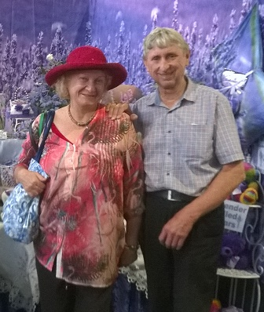
obert has been committed to keeping Australia’s foreign affairs on track, bookkeeping for Chris & Claire’s business, church activities such as social justice initiatives, Men’s Shed, and engagements with the Jung Society, General Semantics Soc. (meeting bi-monthly in Sydney), Christian-Jewish Dialogue, Prisoners Aid Soc., the Canberra Interfaith Forum public meetings, Grevillea Park Landcare, and maintaining various web sites.
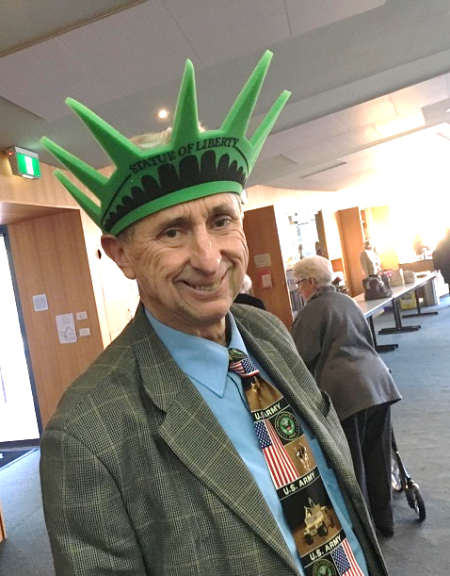
We were pleased to attend the AKML Lecture and Symposium of the Institute for General Semantics at the Princeton Club in New York. Here we met many inspiring people, including particularly Nadine Strossen, Professor of Law at New York University. Robert was honoured to receive the Talbot Winchell Award for work with GS, and to present his paper on “Changes in Free Speech, Hate Speech and Human Rights in Australia”, which was well received.
Robert considers that’s it’s about time to write an epitaph for himself – perhaps it should read: “He was born with a sense of humour, and a sense that the world was mad”…
So “The Days of our Lives” have been rolling along with the various adventures of the James clan. We have been truly blessed with our wonderful family and friends.
The nine grand-children are an important focus for us, so we have some “quality time” together on numerous car journeys up and down the Hume Highway. Enjoying the privileges and responsibilities of grandparenthood, we love our time with the grandchildren, and being able to “hand them back” after visits!
Wishing you all a wonderful Christmas,
and a most healthy, happy and prosperous New Year 2020!
Shalom, from Jeanne and Robert James
and our expanding family.

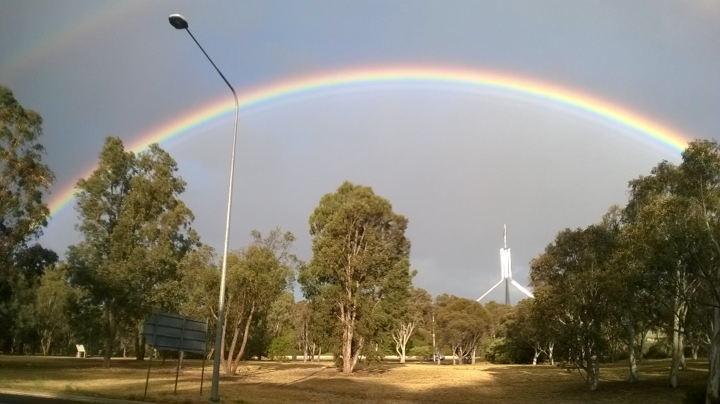

Spotted on the way home from work last week – Nice to see, but no rain, as usual

