thejamesfamily@hotmail.com
www.facebook.com/RobertAndJeanneJames
December 2020

Well, we’re still here, in probably the best place to be in the world! We’ve so much to be grateful for, but we know of many people who are far worse off!

W
ho would have thought, one year ago, what would be coming up (my “Seven Plagues of 2020”): continuing drought, horrid dust, one of the worst bushfire seasons ever, dreadful smoke, hail and flooding, and now this rather tiresome pandemic. Ah well, we seem to be making progress – the only problem we’ve had in Canberra for months is the occasional incoming diplomat. We haven’t even had a proper lockdown. But we can’t stay isolated for ever.

G
oodness me, we haven’t had any new grandchild births for a whole year – surely it doesn’t take all these plagues to arrest our family growth? The short story is that our immediate families are all doing well, despite having lost more friends and acquaintances this year.

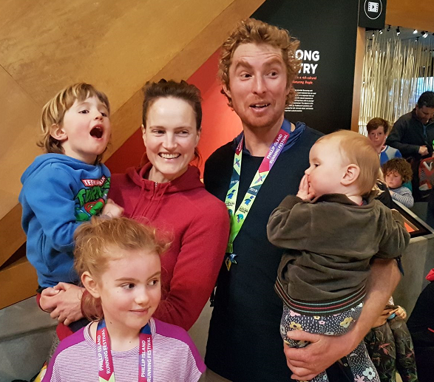
A
drian and Alycia maintain an (almost) idyllic islandic life at Phillip Island. They’ve managed to hold onto their teaching jobs, partly on an on-line basis, and now back to in-person mode.
With schools closed, home-schooling has been required, with its difficulties and stresses, particularly with parents working at the same time.

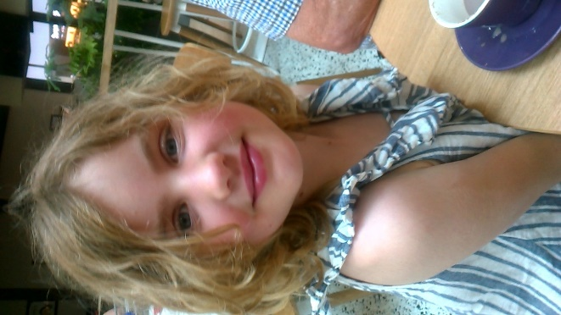
Lily (9) had a special experience when she came by car with Nana and Pa to Canberra in January for a little holiday. This included the hottest day ever recorded in Canberra, drought, dust and bushfire smoke. We had a little sojourn to see Auntie Karen, Uncle Wade, and cousins Jack and Zoe at Central Coast. Then Lily flew home by Qantas as an “unaccompanied minor”, which was highly successful. A problem with this might be that it sets a precedent for the other (eight) grandchildren! Lily is a pianist of note, a violinist, athlete and a great reader.

Would you believe - Rohan is now four, full of life and fun - a lucky lad indeed with sisters older and younger! He has taken well to preschool, developing his social and classroom skills.

And little Iona is already a highly-mobile two - not a baby anymore! She has been enjoying swimming lessons for more than a year now! Nana and Pa are waiting impatiently for the opportunity to come and see her.

C
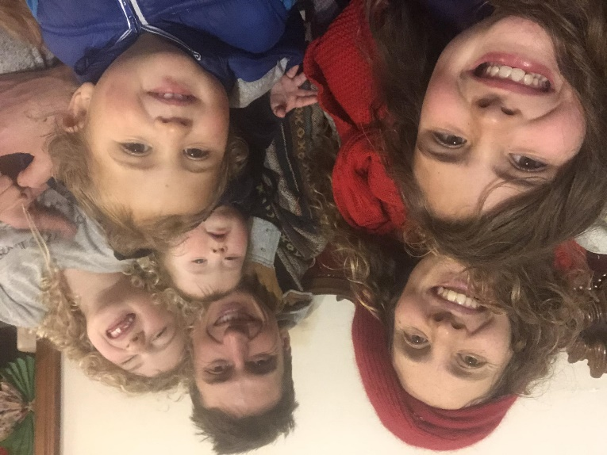
hris and Claire and fam. have been in their “new” home at Millwood (70 Km from Melbourne) for more than a year. The house is indeed a wondrous home for the family of six, plus new doggie Sharlee and five alpacas. Just as well they have a paddock out the back for “extension activities”.

They’ve lost much of their business this year, as festivals etc were cancelled. But this has opened up new opportunities and challenges as they have “gone online” with learning and entertainment activities.

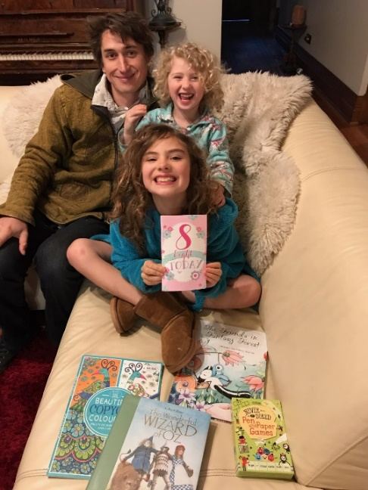
Chris does relief teaching nearby: all high school grades and all subjects! Claire teaches dancing and circus, and they’re re-building their “Dreaming Space” business as Covid-19 restrictions are easing.

Eloura (9) is preparing for fourth grade at the local Steiner school, doing well and a great contributor to her family, school and friends and enhancing her circus skills! She was most tolerant, creative and helpful for her family during the “home schooling” Covid-19 school closure times.

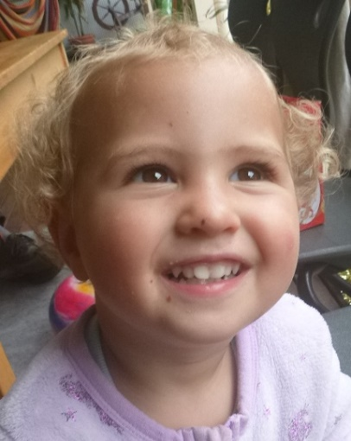
Jasmin (almost 7) is full of life and love, adding fun and sparkle to any entertainment event. She survived the home-schooling lockdown months, and pleased to be back at school again.

Orlando (3) seems to master the skills of living one day at a time: playing, learning and nurturing his baby sister and lavishing attention on their new doggle-pops Sharlee.

Indira (1) is developing physical skills and social engagement day by day, surrounded by a plethora of love and attentive family life.

K
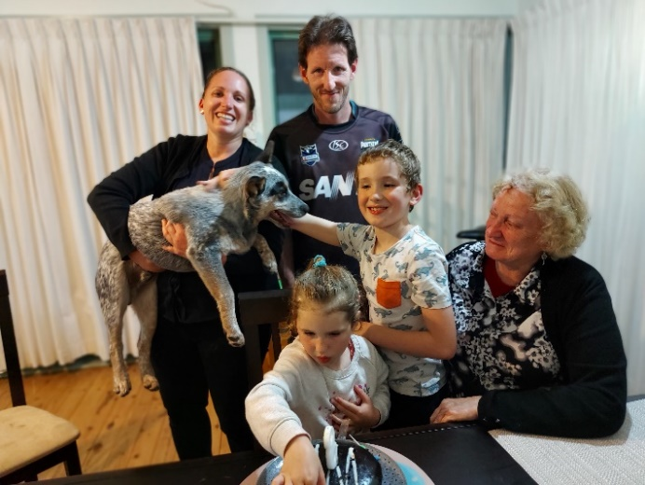
aren and Wade, Jack and Zoe have weathered the various plagues this year at Berkeley Vale. Their much-loved canine family member Ralphie died after almost 20 years. (He was ten years old when Jack was born!) New baby cattle-dog Patchy has livened-up the show and made many friends!

Wade has maintained his “essential work” as Executive Chef at a nursing home. Karen has been successful in moving into personnel-management work consistent with her qualifications and interests. However, the “myHomecare” company has been subject to turbulence at the corporate level, making work life there rather challenging.

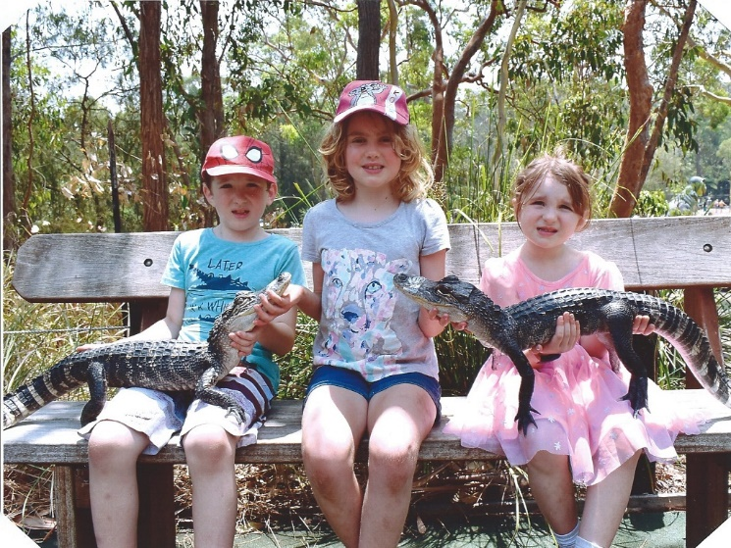
Nana and Pa have had the pleasure and privilege of assisting with home-schooling while schools were closed, but we’re all pleased to see schools open again. During travel restrictions, the families have had lots of practice on Skype and Zoom!

Karen maintains her strong interest in “social running” with friends. They are in a beautiful lake-side location with off-road running paths. She has also engaged in rather challenging cross-country running events in the Blue Mountains! These are also opportunities for family participation.

The family had a beaut south-coast camping holiday, during a window of opportunity as travel restrictions were lifted.

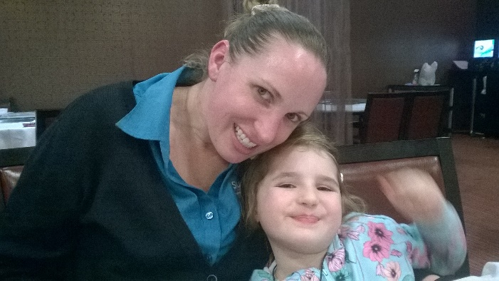
Zoe (turning 6 on 31 December) achieved her ambition in starting Kinda at “Bro Jack’s school”, and has done well. She is enthusiastic in swimming, dancing and Karate, earning certificates and advancing levels. It’s marvellous to see how she embraces the process of “growing up”!

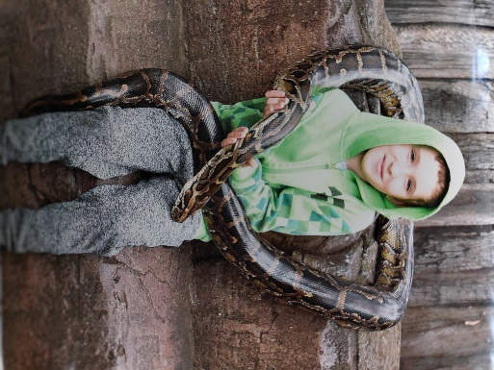
Jack (8) is doing well at school and swimming. He continued his “Little Dragons” Karate lessons at home via Zoom. In-person lessons resumed, and he was awarded the coveted Junior Black Belt , so he is now a force to be reckoned with on the mats.

Jack loves the Reptile Park with is many residents, which he doesn’t mind handling! He has made friends with the Emu in particular. His collection of dinosaurs, snakes and spiders continues to increase, along with his great interest and knowledge of these creatures great and small.

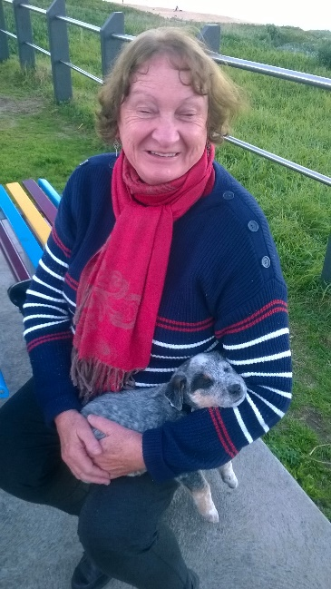
J
eanne works as a relief teacher, currently at the preschool close to home at Watson (Canberra). She loves the infants, but finds the paperwork and bureaucracy rather tiresome. Preschool teaching is not what it used to be!

We haven’t had any overseas travel this year (for obvious reasons), but we’ll see what we can do next year for some domestic destinations. Jeanne awaits resumption of other group activities such as Indian dancing and Tai Chi. Her 70th birthday party was quite a hoot, with 45 people in the hall, and our three children and families “Zooming in”!

Jeanne’s Art Therapy training has been maintained rather successfully in an on-line format, so she shares this with people around the world. Our on-line technologies have indeed been a timely blessing for these locked-down times!
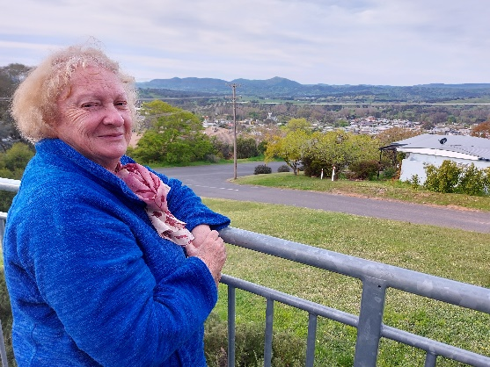
As continuing President of the Canberra Jung Society, Jeanne engages with lots of interesting people. She has been energetic in arranging monthly public meetings with guest speakers, and provides sumptuous suppers for us. Our Christmas party last week was proclaimed as “perfect”! We are most appreciative of our friends with these and other shared interests.

Jeanne’s art retreat at in January at Tumut was cancelled due to bushfires, so we utilised the accommodation for a little holiday in October, and caught up with Jeanne artist friend. Beautiful scenery and historical attractions around Tumut, but terrible destruction of the national park forests.

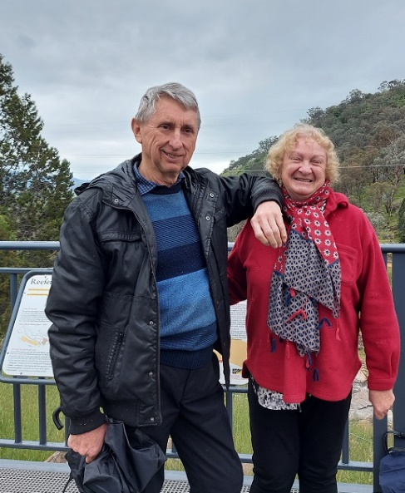
Some of our conferences etc, formerly a highlight of the year, have “gone online”. This has been a mixed blessing; It saves on transport costs etc, and is efficient for short business meetings. But we miss the personal interactions and variety of new experiences.

R
obert “keeps off the streets”, engaged in foreign affairs, family, social and church activities, and indulging interests in public affairs and social justice enterprises.

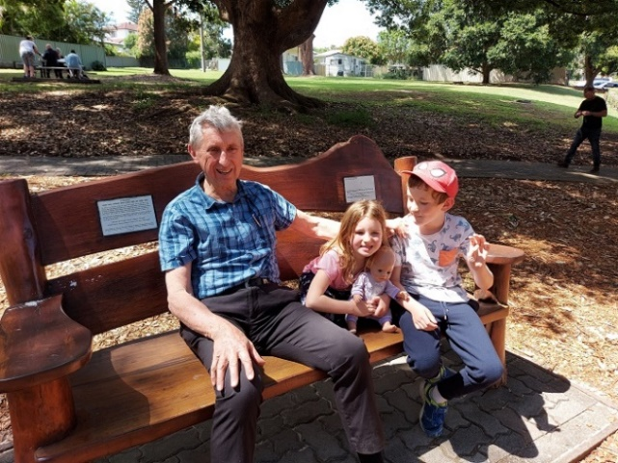
We’re so fortunate that our lives in Canberra have been affected relatively little by the Covid-19 lockdowns. However, some people have had serious after effects from the virus, and great loss from the business and travel restrictions. DFAT have 37,000 people stranded overseas, awaiting repatriation to Australia, and the queue keeps growing!

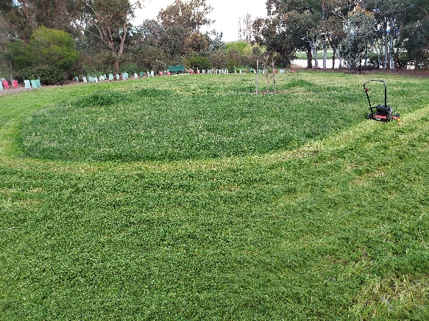
Our wet Spring, has brought on great growth of weeds and lawns, keeping us busy in the garden at home and with our interest at Grevillea Park. The Canberra dams are all full, and we’re promised a wet Summer still to come.

We’ve been frustrated by restrictions on visits to families and friends interstate, but exploited the on-line technology, as seems to be the way to go these days. It’s a poor substitute for real time together, but better than nothing.

We’re certainly hoping for more good news next year!

Wishing you a wonderful Christmas,
and a most healthy and happy New Year 2021!
Namaste, from Jeanne and Robert James
and our extended family.

