Jeanne & Robert James,
thejamesfamily@hotmail.com
www.pcug.org.au/~ajames
December 2022

A
hhhh well, another year of this rather tiresome virus in its various guises – What a drag. And not a trivial matter - new waves keep happening, people sick, sometimes for long time, many hospitalised and some dying. Yet we’re not wearing masks, and not isolating. Jeanne and Robert have managed to elude the dreaded lurgy, but we know that there are no guarantees. And now it’s “war in Europe”, “one in 1,000-year floods”, “skyrocketing interest rates” and “Scomo’s secret ministries” - What next?

Sadly (happily?) we have no immediate family births to report this year and no deaths in the family, but have been to many funerals. In particular we had the death of Ted Holmes (aged 100) in Melbourne, and our good friend Ross White of the Jung Soc. We make an effort when out with “friends our age”, to avoid discussions that are completely focussed on medical anecdotes.

C
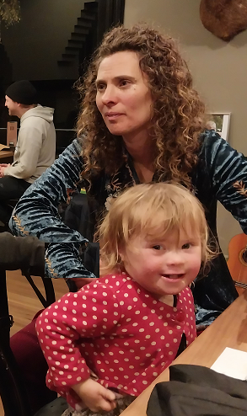
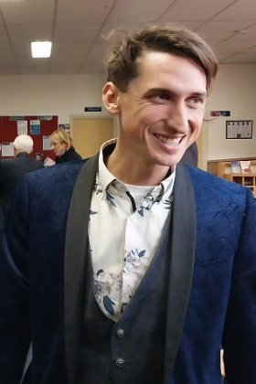
hris and Claire and family have been at Warburton near Melbourne, for more than three years now, and very much part of the “Upper Yarra community”. Their busy lives encompass festival management and performances, domes construction, teaching singing, dancing and circus, ECOSS community activities, Steiner School life, alpaca and horse raising.

Covid-19 lockdowns and vaccination requirements have been a dreadful impediment to their events and entertainment business, but now somewhat eased. This year included an epic journey to visit friends in northern NSW, and families through Central Coast and Canberra.

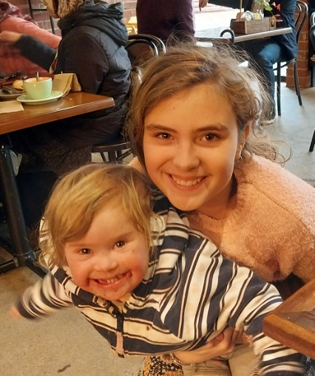
Chris has just had his rather classy 40th birthday party in Warburton’s Alpine Hotel – quite a hoot as you can imagine! Happily, bro Adrian was able to come up from Phillip Island and represent the rest of the family.

Eloura (11) finished fifth grade at the Little Yarra Steiner School, surviving lockdowns and home schoolings. She is quite the young lady now, socially adroit and sophisticated.

Indira (3) is daily becoming more engaged with family and friends, particularly as lockdowns ease and she broaden her horizons!

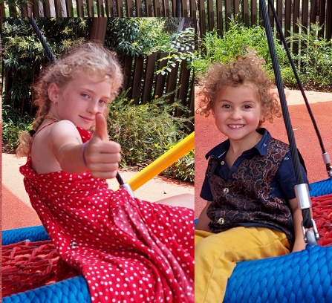
Jasmin (almost 9) is enthusiastically into circus and gymnastic activities, very much part of the “Funky Monkey Family” performances.

Orlando (5) is doing well at the Little Yarra Steiner School, loves dancing and play with sand and trucks. He too plays a unique part in the Funky Monkeys and all manner of extraordinary magical entertainments.
K
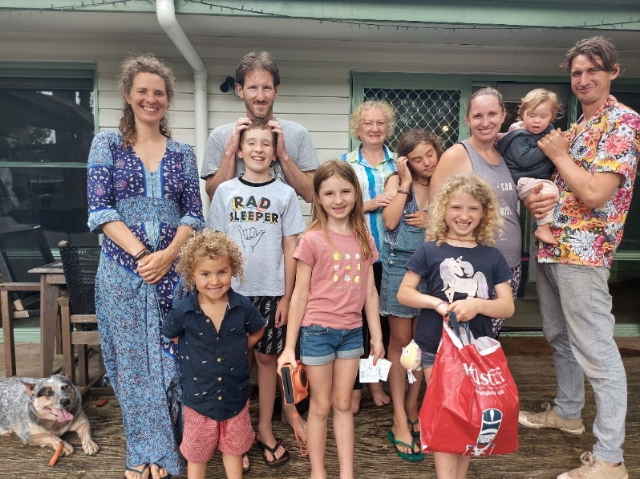
aren and Wade, Zoe and Jack have survived the pandemic and floods at Berkeley Vale (Central Coast, North of Sydney). People living in the lower area between their home and the lake have been getting about in boats, and had multiple cycles of chucking out their furniture and cleaning up.

The family facilitated Chris and family on their camping trip, providing a great opportunity for the mingling of cousins. Nana and Pa camped in the Wyong Grand Hotel from which we engage with the families.
(From left: Patchy, Claire, Orlando, Wade, Jack, Zoe, Jeanne, Eloura, Jasmin, Karen, Indira, Chris)

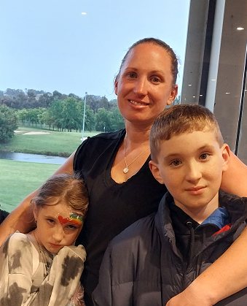
Karen’s professional life in Personnel at Gosford Hospital has kept here more than fully occupied, fortunately allowing for working from home on occasion. She has completed impressing “trail runs” in the Snowy Mountains, Royal national Park, Blue Mountains and recently a 30 Km run near Canberra. Nana and Pa have been privileged to have some minding of grandchildren on some of these events. These activities must be an inadequate demand of her physical and time-management resources, because Karen has taken up kick-boxing, with more gradings and Graduation coming up! These activities are straining the capacity of her “Medals and Ribbons” display rack!

Wade has been working diligently on home improvements, filling-in under the house to prevent Patchy from hiding treasures like mobile phones there, painting and flooring. They’re planning to extend the house with a new bedroom etc, but have been rather dismayed by the interest-rate rises. His Executive Chef skills and experience are always in demand. Wade does not seem to mind the early-morning starts and challenges of working with management, staff and clients, but finds tight budgetary constraints to be stressful.

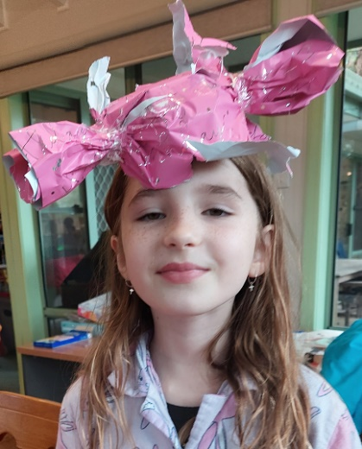
Zoe (turning 8 on 31 December) has done well in Grade-2, despite some illness culminating in tonsillectomy surgery. (Trick question: “What disease would you have if you swallowed Christmas decorations?
Answer: “Tinselitis”!) Zoe is pretty keen on dancing, swimming, Karate (to keep her big bro in order) and getting into gymnastics next year – That should keep her “off the streets”!

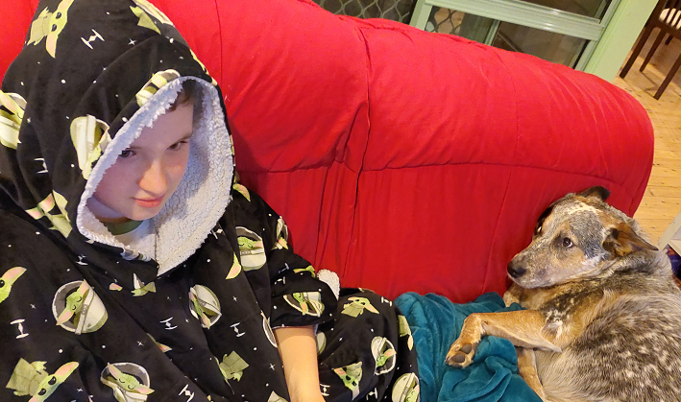
Jack (10) has honed his Chess skills with competitions at school, home and visiting Pa. He has been loyal and consistent in his Karate training, even working on it at home with on-line tuition during pandemic lockdowns. Jack is looking forwards to his Orange Karate graduation. And then there’s computer games!
Patchy relaxes after a hard day on the couch ->
A
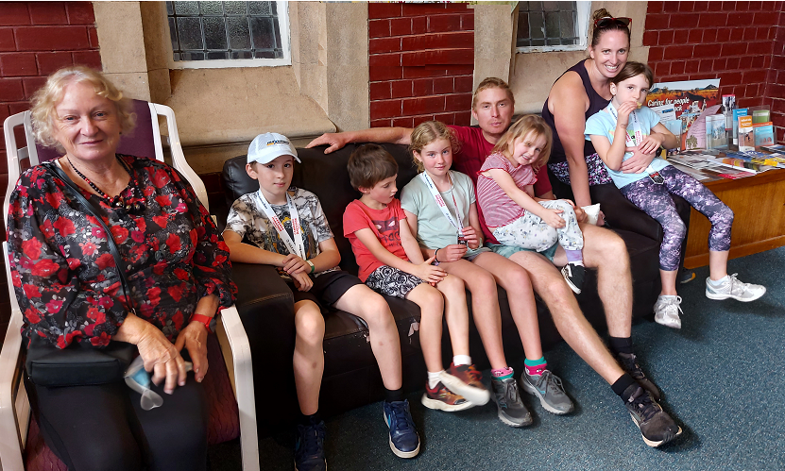
drian and Alycia’s straw-bale house at Phillip Island has withstood tide and tempest for more than eleven years, and holding up well. The family is rather embedded in the Phillip Island community, and takes trips to regional attractions such as Mansfield and Mt. Stirling.
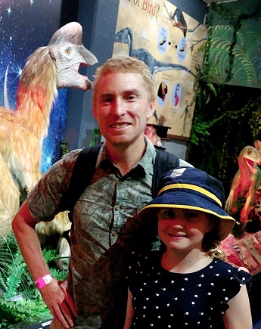

(From left: Jeanne, Jack, Rohan, Lily, Adrian, Iona, Karen and Zoe)
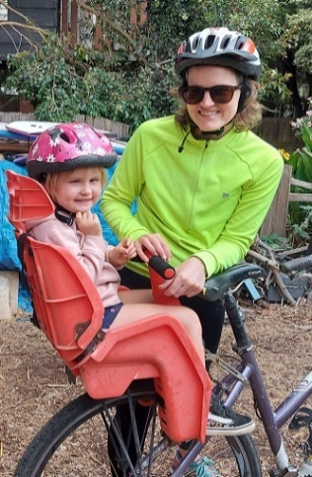
Alycia teaches Humanities at High School on the Isle, quite close to home, and has weathered the “home schooling” and “on-line teaching” pandemic impositions with aplomb. Alycia’s parents have sold-up in Melbourne, and taken to Island life, just across the Bay from San Remo. Their swimming pool seems to be quite a popular attraction for the family!

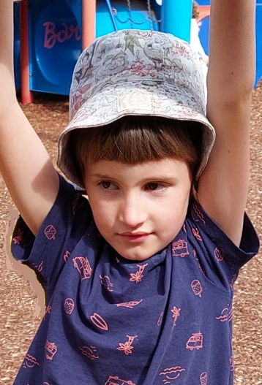
Adrian has a new job as Manager of the Cape Farm, at Cape Paterson, not far from Phillip Isl. This job is particularly fitted to his experience, qualifications and interests, backed by an enthusiastic team. Read all about it on FaceBook! AJ has enlisted as a Scout Leader, in support of Lily’s scouting activities utilising his skills and long experience in outdoor education and leadership work.

Rohan (6) has revealed a creative talent and energy expressed in “comic art”, heretofore unrecognised in the family. He is undertaking hie Karate Blue Belt grading. No more Kinda for Roh … It’s on to First Grade at school next year! Rohan enjoys camping expeditions and Island Life.
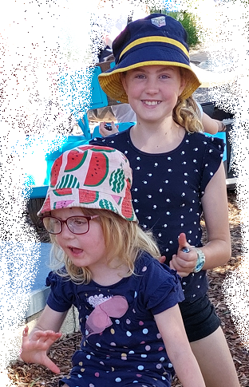
Lily (11) continues her voracious reading journey, straining the Cowes Library literary resources. She has undertaken the prestigious Grey Wolf hike – not such a great challenge for someone steeped in hiking, running and camping experience! Lily is starting competitive gymnastics.

Iona (4) grows each year and developing great interpersonal skills as she learns to manage her older sis and bro! Iona shares her days among pre-school, “Early learning program”, and her Grandpa & Ma. It’s great having Alycia’s parents living on the Isle now, particularly as they have their own swimming pool! Iona follows the family traditions with interest in swimming, horticulture and camping.
J
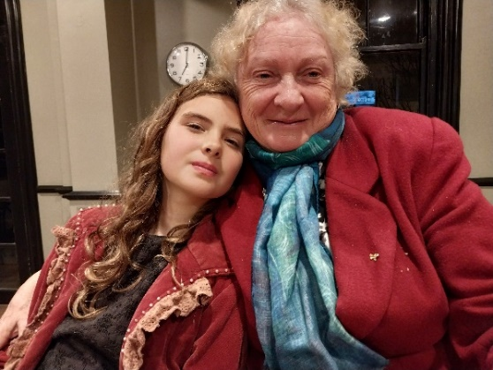
eanne and Robert are active in our church life where we have had various roles and many friends for more than 45 years now! This community of faith has been central to our family “for better, for worse, for richer, for poorer, in sickness and in health …” and the various rites of passage for our expanding family over decades.
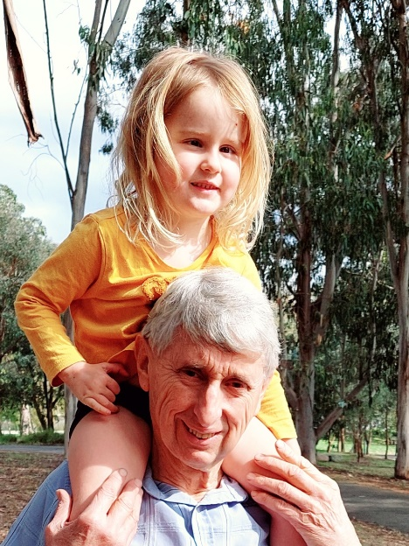
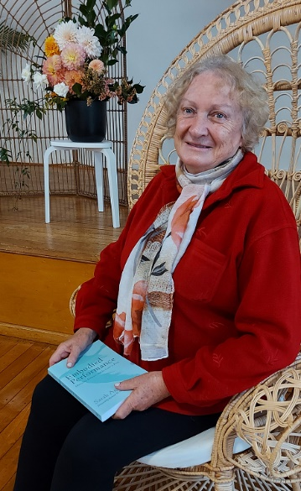
As President of the Canberra Jung Society, Jeanne seems to love providing the suppers, organising guest speakers and maintaining personal contacts. We’ve been able to resume our monthly meetings “in person” again after lockdowns, with the benefit of social contact, music, library and suppers. But now we have the capacity to engage speakers by Zoom from their own homes anywhere in the world!

In the Canberra Interfaith Forum, we work with people of many faith traditions to stage public forums and promote interfaith trust and harmony. This was the eleventh year of our Environment Meditation and Healing Garden (EMHG) at Grevillea Park with planting, watering, mowing, weeding and organising special events.

We have maintained the Australian General Semantics Soc. for more than 30 years, initially with monthly seminars in Sydney, latterly online, enabling our engagement with the GS Community “around the Globe”. We participated in a GS Institute colloquium in New York in 2019, and departed Manhattan just in time to avoid the pandemic!

Jeanne has been much in demand as Relief Teacher, with so many teachers sick or isolated by Covid. She has continued her personal and professional development with courses on teaching children with special needs (Autism etc), art therapy and other teaching innovations. While hoping to cut back on teaching hours, she enjoys the engagement and rewards of working with young children, especially when one of them comes to her with a “World’s Best Teacher” mug and chockies etc!

One of Jeanne’s school students, his brother and mother were all killed in a particularly sad incident, of which we still do not know all details. This was rather a terrible blow for the people who knew this family.

Robert keeps himself off the street” with activities as above, taking the King’s Shilling for work in Foreign Affairs, and maintaining contact with friends and family up and down the Hume Highway.

(A plumper, link-infested version of this self-indulgent note is available on our website)
Wishing you a wonderful Christmas,
and a most healthy and happy New Year 2023!
Shalom, from Jeanne and Robert James
and our extended family.

