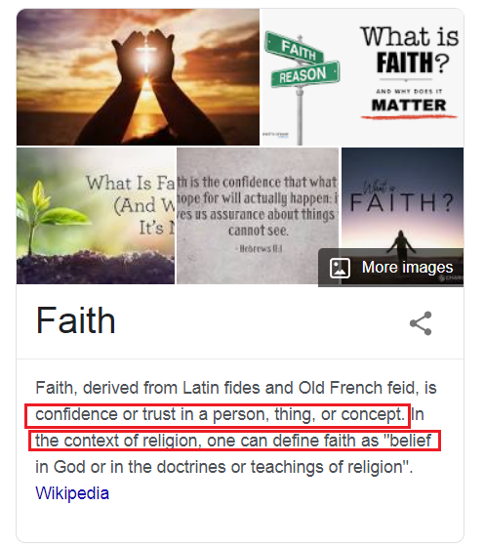

1. From the above, faith doesn't necessarily align with religion. What do you have faith in?

2. Can belief be separated from faith?

(while you're considering this, how are you ordering your thoughts????), describe it??

------------------------------------------------------------------------------------------------

What Is Faith?



Faith inspired transcendence?

A tragic leap of faith - Thanatos?

by Jim Haeffele

What is faith? It is trust, assurance and confidence in God. Living faith is shown by service and obedience to God. How can we increase our faith?

3. What is common in the two perspectives?

4. Can faith be quantified? What scale could we use?

------------------------------------------------------------------------------------------------

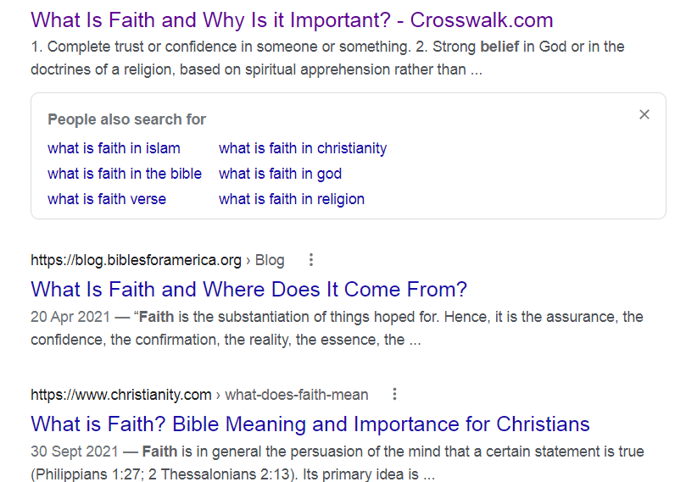

The above is a screenshot of my attempts to pin down the word faith on the net, the word seems to fall securely in the realms of religious strivings.

5. Is there a place outside of religion for the use of this word?