Scientific Faith Is Different From Religious Faith

Not all beliefs are equal.

By [Paul Bloom](https://www.theatlantic.com/author/paul-bloom/)

When the literary theorist Stanley Fish chastised atheists such as Richard Dawkins, he wrote, “Science requires faith too before it can have reasons,” and described those who don't accept evolution as belonging to “a different faith community.”

It is true that scientists take certain things on faith. It is also true that religious narratives might speak to human needs that scientific theories can’t hope to satisfy.

6. This is a one of those cornerstone questions, where does science place its 'faith'?

### Author

1. [**[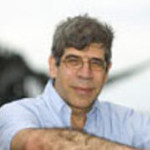](https://theconversation.com/profiles/jerry-coyne-378256)Jerry Coyne**](https://theconversation.com/profiles/jerry-coyne-378256)

Professor Emeritus of Ecology and Evolution, University of Chicago

And yet, without supporting evidence, [Americans believe a number of religious claims](https://theharrispoll.com/new-york-n-y-december-16-2013-a-new-harris-poll-finds-that-while-a-strong-majority-74-of-u-s-adults-do-believe-in-god-this-belief-is-in-decline-when-compared-to-previous-years-as-just-over/): 74 percent of us believe in God, 68 percent in the divinity of Jesus, 68 percent in Heaven, 57 percent in the virgin birth, and 58 percent in the Devil and Hell. Why do they think these are true? Faith.

7. See anything in the above that stands out as,,,anomalous?

FAITH, REASON, AND SCIENCE

## What Is It

Does faith obscure reason? Does reason obscure faith? Or perhaps their subject matters are different. Faith might address one area of our lives and reason and science another. Faith may allow us to see meaning, values, and God, while reason sees everything else, whatever that may be. Or perhaps faith and reason are fundamentally intertwined. Is faith void of reason? Is it irrational to be faithful? Are science and rationality void of faith? John and Ken welcome Nancey Murphy, author of Did My Neurons Make Me Do It?: Philosophical and Neurobiological Perspectives on Moral Responsibility and Free Will, to explore the meaning of faith and the place of faith and reason in religion, scientific practice, and our knowledge of ourselves and the world around us.

One aspect of GS is the exploration of the nature of words and language and the complex interactions with behaviours.

Up to this point, faith appears immerged in viewpoints and linked with other words that defy clear definitions.

8. How can we get clarity?

Faith isn't the only word that suffers in this way, some more word networks are: consciousness, soul, mind, spirit, being, essence, psyche, reality, entity, thing.

9. Any others that can be grouped with the above?

10. What would be a strategy in addressing these terms from a GS perspective?

Lets return to processes 'less confusing' than these words that wriggle in meaning. Have you ever lost your keys, searched a long time and found them in the open waiting to be discovered? asked for a name and found it on the tip of the tongue but couldn't quite voice it? We are entering in the world of implicit learning and other uncomfortable but rich realms. Faith can at least rent some space here. Science needs to find comfort here too rather than ignore it.

11. Here are two words: begin and benign, how they similar? - 5 seconds.

12. When did you last eat chips?

13. Close your eyes and picture a cloud with an apple inside.

Describe what happened as you were processing the answers to these tasks.

13. How does GS relate to these processes?

Since most of our time seems to be word free, it would be useful to see the range of aspects of that world. Name these images.

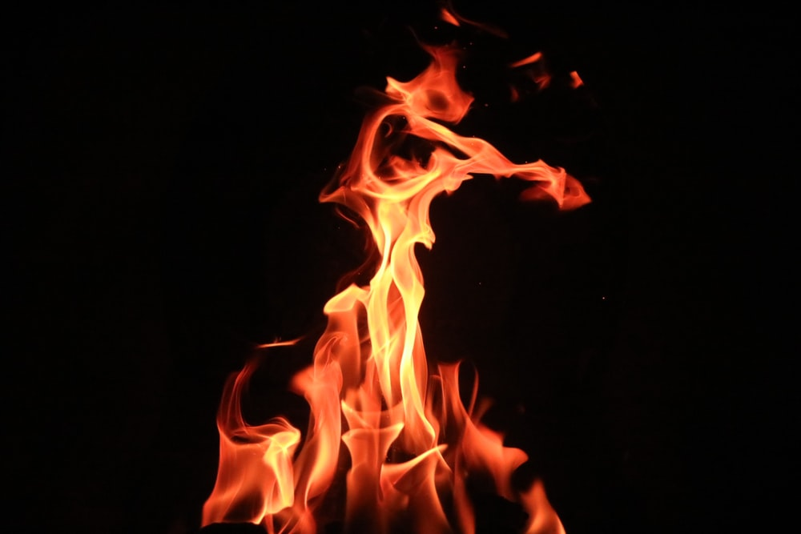

_________________________________________________

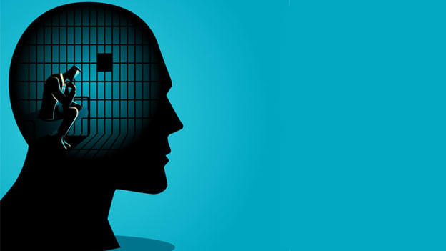

_____________________________________________________



________________________________________



________________________________________________________



________________________________________________________________

14. As a group, what could be one summary word to represent them?

demonstration 1

Here are some inexplicable but fundamental aspects of science that contributes in giving science its raison d’être:

1. Perception of hardness

2. The perception of force from nothing - no thing

3. Inexplicable oneness in mathematics and physics of 'inertial' mass and 'gravitational' mass.

3. Different perceptions of formula aspects differing only by number NOT variable: 1/2 MV2 and MV

4. False perceptions, but mathematically necessary, of entity (something within a *boundary*).

demonstration 2 on magic

15. Logic and reason have been used as a defining aspect of homo sapiens, how important are these processes in the light of non conscious predominance?

16. Can a brain fashioned by evolution fathom events NOT linked to survival?? (a big question)

The 4 groups of examples of accepted anomalies in science are rarely questioned, but Where is faith in science?? facts perhaps? evidence? consistency of phenomena? predictability of events?

17. Discuss those aspects attributed to science.

So science may be clothed in the above, but what of the beast's behaviour

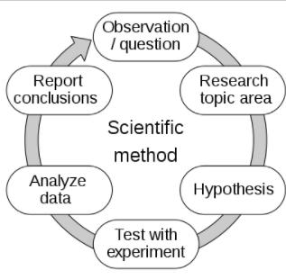

18. A much respected and loved colleague of ours was known to ask: about a person's thesis. Where is thesis on this circular diagram? Antithesis e.g.  "**Man proposes, God disposes**."

Clothes, behaviour, and .......

19. Scepticism has been much maligned as a wet blanket of creatively, yet a fundamental strategy of science. Science likes proof, is there such a thing via statistics? p = .05 likely??

**20. Has faith a place in science without proof, like religion?**