HAND COMPUTER
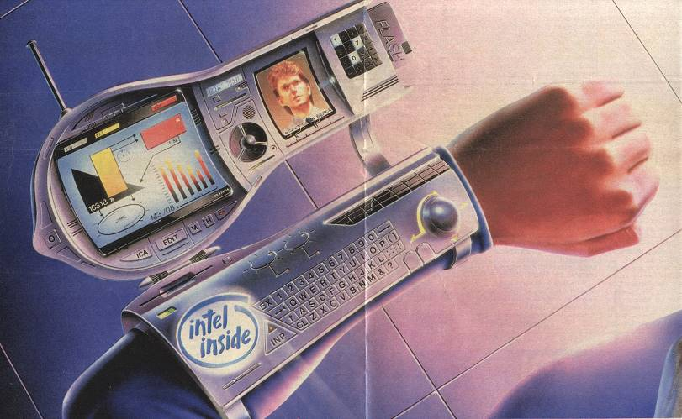
EQUIPMENT STATISTICS
TL Type Vol Wt Price
O 11 Hand Computer-11 0.2 litres 0.5 kg Cr1,000
O 13 Hand Computer -13 0.2 litres 0.5 kg Cr1,000
O 15 Hand Computer -15 0.1 litres 0.3 kg Cr1,000
O 16 Hand Computer -16 0.1 litres 0.1 kg Cr1,000

SUPPLEMENTAL STATISTICS (OPTIONAL)
Charge Operating Power
TL Duration Noise Usage Comments
O 11 7 days soft clicks 1W Mem 100M words
O 13 4 weeks silent 1W Mem 500M words
O 15 8 weeks silent 1W Mem 1,000M words
Tech level 15 version illustrated O 16 12 weeks silent 1W Mem 5,000M words

USAGE RECORD (OPTIONAL)
CUSTOMISING NOTES: Each square represents 7 days of usage
O TL11:
O TL13:
O TL15:
O TL16:

DESCRIPTION The hand computer is a powerful supercomputer (equivalent to a Model/1 in computing power) that is small enough to be worn on the wrist. The hand computer handles the storage, retrieval and processing of vast quantities of data (text, graphics, sounds and images) with remarkable speed and accuracy.

The computer also includes a data communications link for hooking into world computer nets available in most urban areas of TL 8+worlds, or globally from any point on the world’s surface on most TL 11+ worlds. The computer link allows sending and receiving electronic mail, or contacting any other hand computer user for direct voice and/or visual communication. Aboard ship, it can serve as a computer terminal.

Due to its many powerful features, the hand computer is essentially a portable assistant, extending the capabilities of its user in many ways.

TASK LIBRARY - USAGE To use a hand computer for data retrieval:
Routine, Computer, EDU, 5 sec (unskilled OK)
Referee: Time duration applies to a keyword lookup. For a general search, modify the time increment by up to 1 hour.

To gain skill augmentation using a hand computer:
Routine, [skill], EDU, 1 min
Referee: If the character is unskilled in the task to be augmented, make this task Formidable. On success at this task, grant a +1 on the next task using the augmented skill; for exceptional success grant a +2.
If successful at an unskilled augmentation, grant a temporary skill-0.
The [skill] refers to the skill being augmented – thus the more skilled a character is, the easier it becomes to augment that skill with a hand computer. Use INT if unskilled.
Only obviously technical tasks which use EDU and are not uncertain can benefit from hand computer augmentation.

TASK LIBRARY - REPAIR To repair a damaged hand computer:
[varies], Electronics/Computer Engineering/Computer-2, EDU, [varies]
Referee: Difficulty depends on the damage level: use the standard damage and repair guidelines. Time increments for shop repair are as follows:
superficial damage 1 min
minor damage 10 min
major damage 5 hrs
destroyed 40 hrs
For field repair, double the time increment, in addition to other standard increases.

