MEGABOINGTM GRAV POGO STICK
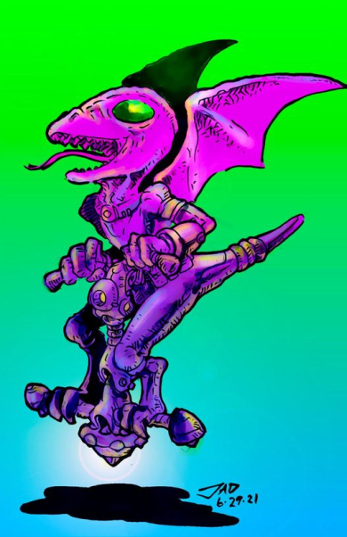
EQUIPMENT STATISTICS
TL Type Vol Wt Price
O 12 Pogo Stick-12 222 litres 62.2 kg Cr2,900

SUPPLEMENTAL STATISTICS (OPTIONAL)
Charge Operating Power
TL Duration Noise Usage Comments
O 12 4 weeks boing 0.05 MW none

USAGE RECORD (OPTIONAL)
Each square represents 7 days of usage
O TL12:

CUSTOMISING NOTES:
O Radar altimeter and speedometer
O Glove compartment
O Tassels on handles

Tech level 12 version illustrated with Droyne Sport by Joey A. Docil

DESCRIPTION Brought to you by the fun-loving team at Famille Spofulam Toys & Games and designed for adventurous children everywhere, the MegaBoingTM Grav Pogo Stick is a fluorescent 1.5m structcomp shaft with grab handles at the top and a disc acting as a footrest at the base (with drive and battery). A spring-propelled stick in the shaft generates a vertical thrust component, allowing the rider to hop along a surface by varying the shaft angle as the spring is compressed.

A dedicated TL 12 computer controls an inbuilt antigravity drive to balance the pogo stick while in motion (within safe operational parameters to permit some lateral motion) and to counteract 95% of a 1G external gravity field, save between the moment where the spring first contacts the ground and when spring has compressed over 75% (adjustable by parents to provide for more or less impetus) of its total travel. Once spring (actually a TL-10 smart-fluid variable resistance shock absorption cylinder) has reached a parentally approved maximum travel point, thrust resumes to counteract the external gravity field until spring has reached full extension, at which point thrust reverts to 95% of external field.

Once maximum parentally approved altitude is attained, parentally programmed safety cut-offs adjust velocity during descent portion of trajectory to remain within parentally approved limits. Other safety features include deadman switches on the handles to detect child losing grip, and a safety harness to ensure child remains on board (pogo stick will not operate without harness being attached). Helmet & goggles must be user-supplied.

The box it comes in is plastered with advisory warnings against operating near potentially hazardous obstacles such as trees, tall buildings, swamps, large bodies of water, overhead power lines and airports, and against tampering in order to allow child to reach orbit.

TASK LIBRARY - USAGE To use a pogo stick within parental-approved limits:
Routine, Grav Belt, DEX, 5 sec (unskilled OK)

To modify safety overrides and remove the hardware governor:
Difficult, Gravitics/Computer, EDU, 10 min
Referee: Tampering with the governor could enable a theoretical acceleration of up to 8 G's (7.5 or so with child rider on board) and the ability to reach orbit.
*** FST&G will not accept any liability arising from such dangerous misuse and strongly condemns the sort of irresponsible mind that would contemplate it. ***

TASK LIBRARY - REPAIR To repair a damaged pogo stick:
[varies], Gravitics/Electronics, EDU, [varies]
Referee: Difficulty depends on the damage level: use the standard damage and repair guidelines. Time increments for shop repair are as follows:
superficial damage 1 min
minor damage 10 min
major damage 5 hrs
destroyed 40 hrs
For field repair, double time increment in addition to other standard increases.
Stats and description of the MegaBoingTM Grav Pogo Stick are taken from ELLIOT, Roderick Darroch, The Complete Famille Spofulam Catalogue, Winter 1997, c.1997-99, p 29.
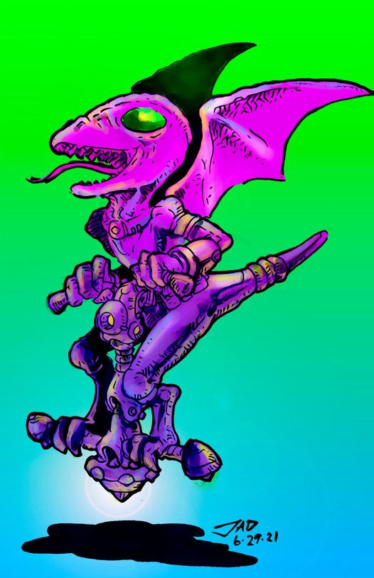
Sport On A Stick (Joey A. Docil, June 2021)

