17. Bunjil’s Cave near Stawell, Victoria
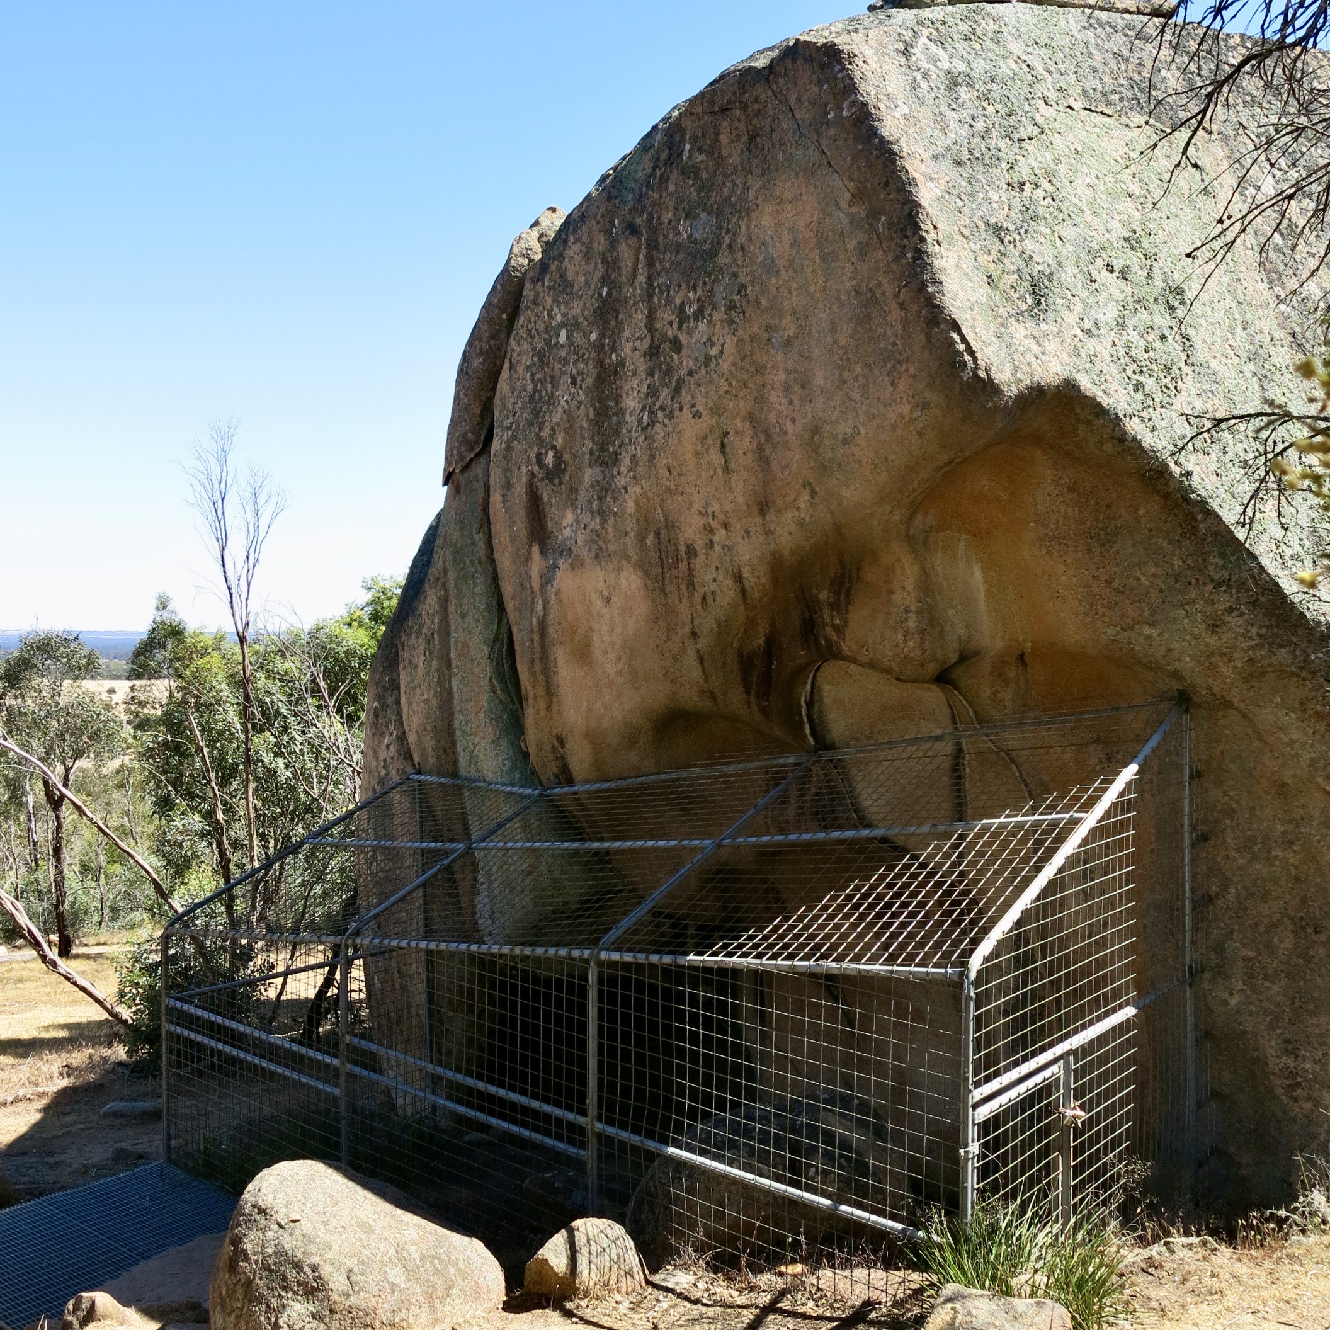
Photo: R. Barz 2018

18. Bunjil and His Two Dingoes
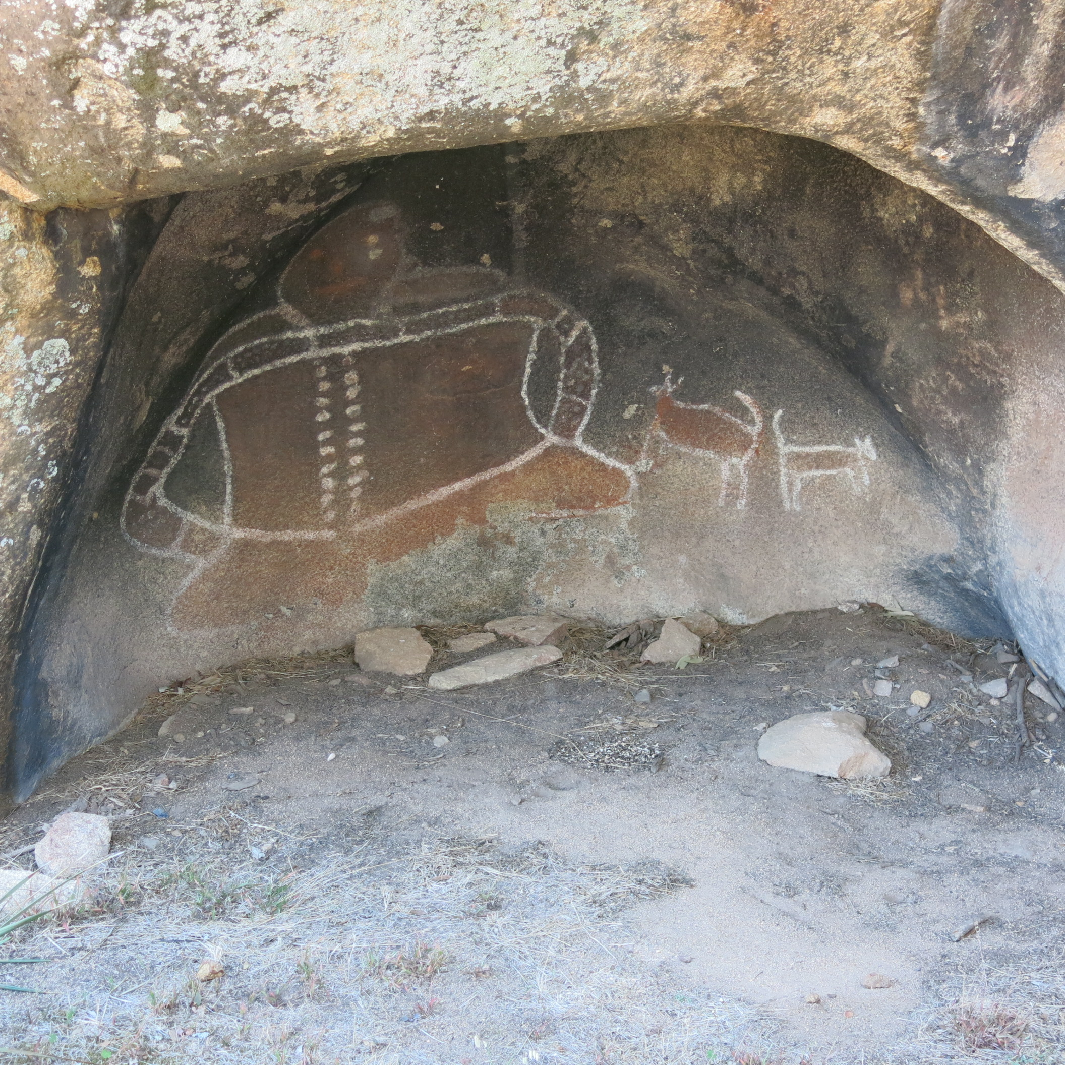
Photo: R. Barz 2018

