

**Jung’s ‘Flying Saucers’**

A Modern Myth of Things Seen in the Skies

John A Gillam

**John Gillam provided a review of Carl Jung’s book *Flying Saucers: A modern myth of things seen in the skies* [1] to the June 2025 meeting of the Society. Jung's main message was that UFO sightings and beliefs represent a modern myth arising from the collective unconscious, symbolising humanity's psychological need for wholeness and transcendence in response to the anxieties and divisions of the Cold War era (1947-1991).**

**Jung wrote the book in German in 1958 as**

***Ein moderner Mythus: Von Dingen, die am Himmel gesehen werden***

**with its first English translation in 1978.**

**C**arl Jung's *Flying Saucers* book offers a unique psychological analysis of the UFO phenomenon that captivated public imagination during the Cold War era. Published in 1958, this work does not focus on the potential extraterrestrial origins of these objects but rather examines the psychological and cultural significance of UFO sightings and their impact on the collective psyche as a product of the Cold War period. It reflects the anxieties and tensions of the time. Jung proposes that these circular objects represent archetypes from the collective unconscious, symbolising wholeness and unity in a fractured world.

The Cold War context is crucial to understanding Jung's perspective. In an era marked by nuclear threats and ideological divisions, the appearance of mysterious objects in the sky became a canvas for projecting collective fears and hopes. Jung saw these sightings as symptoms of a psychic epidemic, revealing deep-seated anxieties and a yearning for cosmic intervention or salvation.

Jung was particularly interested in the wave of UFO sightings in the United States and Europe. In his book he references numerous American cases and media reports. He also discusses sightings in Switzerland, France and Italy.

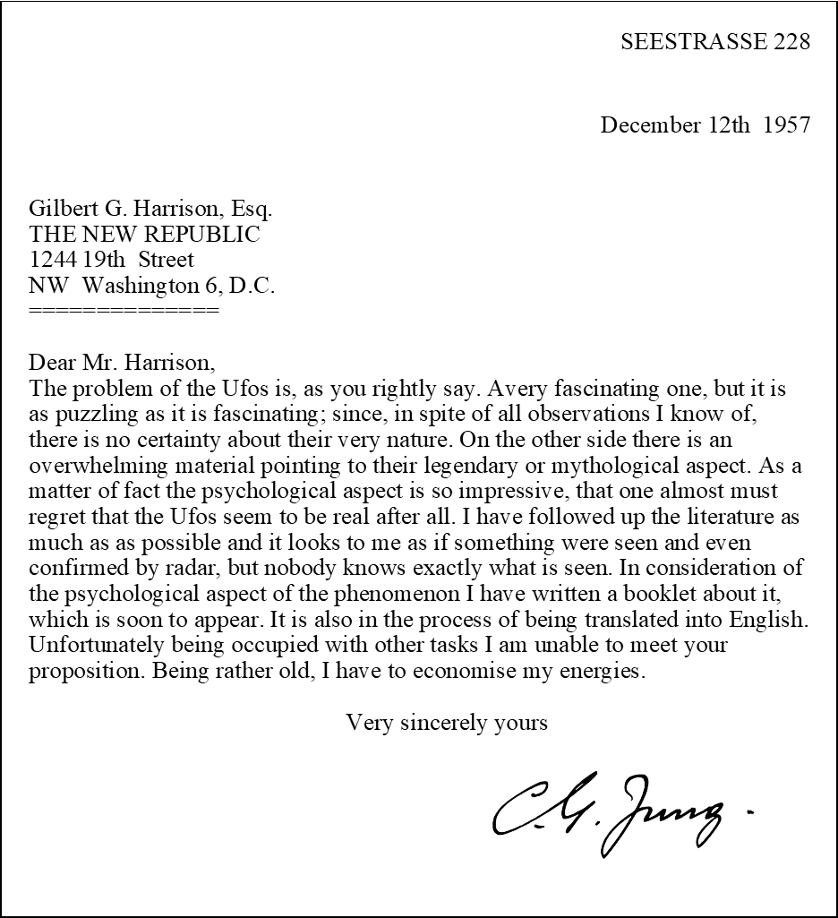Jung's interest in the topic was so significant that he collected a substantial amount of material on UFOs over several years before writing his book. In 1957, Jung wrote a letter to the publisher Henry Regnery, who was preparing to publish the English translation of Jung's book on flying saucers. The purpose of that letter was to clarify his position on UFOs and to prevent any misunderstanding about the nature of his work. That letter is copied below.

Retyped letter from Carl Jung about UFOs. 1957. Original in poor condition -- Flashbak

This letter is significant because it demonstrates Jung's careful approach to a controversial subject. He was trying to navigate between acknowledging the widespread interest in UFOs and maintaining his focus on their psychological significance, without being drawn into speculation about their physical nature. It also shows Jung's awareness of the potential for his work to be misunderstood or misrepresented, especially given the intense public interest in UFOs at the time.

He notes that many UFO sightings and encounters involve themes of surveillance, abduction, or secret contact with authorities – all resonant with the espionage and security concerns of the era: "The fear of invasion from the air, nurtured by the vulnerability of our world to air attack, has made the sky a place of projection for our deepest anxieties" [1, p.23].

In his book, Jung begins by acknowledging the widespread nature of UFO reports and the intense emotions they evoke. He writes, "As we know from ancient Egyptian history, they are manifestations of psychic changes which always appear at the end of one Platonic month and at the beginning of another" [1, p.3]. This sets the tone for his exploration of flying saucers as harbingers of significant cultural and psychological shifts.

Central to Jung's analysis is the concept of the mandala, a circular symbol representing wholeness and integration. He draws parallels between the round shape of reported UFOs and this archetypal image: "The circular shape of the UFO is important as it is the symbol of wholeness; it is a mandala... It is a worldwide symbol which expresses the totality of the self” [1, p.20]. This interpretation suggests that UFO sightings might represent a collective psychic attempt to find unity and completeness in a divided world.

Jung delves into the religious and mythological aspects of the phenomenon, noting similarities between UFO encounters and traditional visionary experiences. He suggests that in a secular age, the psychological need for transcendent experiences finds expression through technological rather than religious imagery: "What we read about them is comparable to the old miracle stories of sudden apparitions... In modern times the myth-forming powers of the unconscious seem to have turned to this new form of manifestation" [1, p.14].

**The collective unconscious and archetypes**

Jung's theory of the collective unconscious plays a crucial role in his interpretation of the flying saucer phenomenon. He argues that these sightings tap into deep-seated archetypal images shared by all of humanity. The circular shape of the UFOs, according to Jung, is particularly significant as it resonates with the archetype of the Self – the totality of the psyche.

He elaborates on this connection: "The Self is not only the center, but also the whole circumference which embraces both conscious and unconscious; it is the center of this totality, just as the ego is the center of consciousness" [1, p.22]. In this context, Jung suggests that the appearance of flying saucers in the collective imagination represents a psychic attempt to achieve wholeness and integration in a fragmented world.

Jung also explores how the UFO phenomenon interacts with other archetypal figures, such as the Divine Child or the Saviour. He notes that many UFO narratives involve themes of cosmic salvation or warnings about humanity's destructive path, reflecting archetypal patterns of redemption and apocalypse: "The UFOs play the role of 'gods from outer space' who come to warn mankind or to bring them help in an hour of need" [1, p.18].

**Psychological projection and compensation**

A key aspect of Jung's analysis is the concept of psychological projection. He argues that the flying saucer phenomenon represents a mass projection of unconscious content onto the skies. This projection, Jung suggests, serves a compensatory function, balancing out the conscious attitudes of a society gripped by Cold War paranoia and technological advancement.

Jung writes, "Projection is an unconscious, automatic process whereby a content that is unconscious to the subject transfers itself to an object, so that it appears to belong to that object" [1, p.12]. In the case of flying saucers, he suggests that the collective psyche is projecting its need for unity, salvation, and transcendence onto mysterious aerial phenomena.

This compensatory function is particularly important in Jung's view, as it helps to balance the rational, materialistic worldview dominant in modern society. He suggests that the appearance of flying saucers in the collective imagination serves to inject a sense of mystery and spiritual significance into a world increasingly dominated by scientific rationalism: "In a time when science has deprived nature of its mysteries, there is still an overwhelming need to believe in the marvellous" [1, p.16].

**Mass psychology and rumour**

Jung dedicates significant attention to the social dynamics of the UFO phenomenon, examining how rumours spread and beliefs take hold in the collective psyche. He views the proliferation of UFO stories as a form of collective myth-making, revealing important aspects of modern mass psychology.

"Rumour-spreading carries with it an air of sensationalism and excitement which many people find extremely enjoyable," Jung observes [1, p.10]. He suggests that the emotional charge of UFO narratives contributes to their rapid spread and the intensity of belief they inspire. This analysis extends beyond flying saucers to offer insights into how modern myths and conspiracy theories propagate in society.

Jung also explores the role of the media in shaping and spreading UFO narratives. He notes that press coverage, both sensationalist and skeptical, plays a crucial role in amplifying the phenomenon: "The press, with its preference for sensational news, has naturally done its best to keep the public interest alive" [1, p.11].

**Symbolic interpretation and modern spirituality**

Throughout the book, Jung emphasises the importance of symbolic thinking in understanding psychological phenomena. He argues that the flying saucer, as a symbol, represents more than just a physical object – it embodies collective hopes, fears, and spiritual longings.

Jung suggests that the UFO phenomenon reveals a spiritual hunger in modern society, a yearning for meaning and transcendence in an age of scientific materialism. He writes, "The psychological situation of mankind and the increasing scientific and political complexity of our modern world have created a widespread feeling of anxiety and insecurity" [1, p.24]. In this context, flying saucers serve as modern-day angels or deities, offering the promise of cosmic significance and potential salvation.

This symbolic approach extends to Jung's interpretation of individual UFO encounters and abduction narratives. He views these experiences not as literal events, but as symbolic expressions of psychological processes, akin to dreams or visions: "The symbolism of these visions points to a content of great emotional significance and numinous quality" [1, p.26].

**Conclusion**

Jung's book on flying saucers offers a profound exploration of a modern myth, demonstrating how psychological analysis can illuminate cultural phenomena. By interpreting UFO sightings as expressions of collective psychological needs rather than physical events, Jung provides insights into the human psyche's response to times of crisis and change.

The book's enduring relevance lies in its approach to understanding mass beliefs and their psychological underpinnings. As Jung concludes, "We have here a golden opportunity of seeing how a legend is formed, and how in a difficult and dark time for humanity a miraculous tale grows up of an attempted intervention by extra-terrestrial 'heavenly' powers" [1, p.25].

In an age where conspiracy theories and unverified beliefs continue to shape public discourse, Jung's work offers valuable tools for understanding the psychological roots of such phenomena. It reminds us that beyond the question of their physical reality, beliefs about flying saucers and similar phenomena reveal important truths about human psychology and our collective response to uncertainty and fear.

Ultimately, *Flying Saucers* stands as a testament to Jung's unique ability to bridge the worlds of psychology, mythology, and cultural analysis. It challenges us to consider the flying saucer not just as a potential physical object, but as a potent symbol of humanity's enduring quest for meaning, unity, and transcendence in an ever-changing world.



AI rendition of flying saucer. Pixabay: Kyraxys

**Jung's Psychological Approach**

Jung begins by acknowledging the widespread nature of UFO reports and the intense emotions they evoke. He writes, "As we know from ancient Egyptian history, they are manifestations of psychic changes which always appear at the end of one Platonic month and at the beginning of another" [1]. This sets the tone for his exploration of flying saucers as harbingers of significant cultural and psychological shifts.

Central to Jung's analysis is the concept of the mandala, a circular symbol representing wholeness and integration. He draws parallels between the round shape of reported UFOs and this archetypal image: "The circular shape of the UFO is important as it is the symbol of wholeness; it is a mandala... It is a worldwide symbol which expresses the totality of the self" [2]. This interpretation suggests that UFO sightings might represent a collective psychic attempt to find unity and completeness in a divided world.

Jung delves into the religious and mythological aspects of the phenomenon, noting similarities between UFO encounters and traditional visionary experiences. He suggests that in a secular age, the psychological need for transcendent experiences finds expression through technological rather than religious imagery: "What we read about them is comparable to the old miracle stories of sudden apparitions... In modern times the myth-forming powers of the unconscious seem to have turned to this new form of manifestation" [3].

**The Collective Unconscious and Archetypes**

Jung's theory of the collective unconscious plays a crucial role in his interpretation of the flying saucer phenomenon. He posits that these sightings tap into deep-seated archetypal images shared by all of humanity. The circular shape of the UFOs, according to Jung, is particularly significant as it resonates with the archetype of the Self – the totality of the psyche.

He elaborates on this connection: "The Self is not only the centre, but also the whole circumference which embraces both conscious and unconscious; it is the centre of this totality, just as the ego is the centre of consciousness" [4]. In this context, Jung suggests that the appearance of flying saucers in the collective imagination represents a psychic attempt to achieve wholeness and integration in a fragmented world.

Jung also explores how the UFO phenomenon interacts with other archetypal figures, such as the Divine Child or the Saviour. He notes that many UFO narratives involve themes of cosmic salvation or warnings about humanity's destructive path, reflecting archetypal patterns of redemption and apocalypse: "The UFOs play the role of 'gods from outer space' who come to warn mankind or to bring them help in an hour of need" [5].

**Psychological Projection and Compensation**

A key aspect of Jung's analysis is the concept of psychological projection. He argues that the flying saucer phenomenon represents a mass projection of unconscious content onto the skies. This projection, Jung suggests, serves a compensatory function, balancing out the conscious attitudes of a society gripped by Cold War paranoia and technological advancement.

Jung writes, "Projection is an unconscious, automatic process whereby a content that is unconscious to the subject transfers itself to an object, so that it appears to belong to that object" [6]. In the case of flying saucers, he posits that the collective psyche is projecting its need for unity, salvation, and transcendence onto mysterious aerial phenomena.

This compensatory function is particularly important in Jung's view, as it helps to balance the rational, materialistic worldview dominant in modern society. He suggests that the appearance of flying saucers in the collective imagination serves to inject a sense of mystery and spiritual significance into a world increasingly dominated by scientific rationalism: "In a time when science has deprived nature of its mysteries, there is still an overwhelming need to believe in the marvellous" [7].

**The Cold War Context**

Jung's analysis is deeply rooted in the historical context of the Cold War. He sees the flying saucer phenomenon as a psychological response to the existential threats and global tensions of the era. The fear of nuclear annihilation, the ideological divide between East and West, and the rapid pace of technological change all contribute to a collective psychological state ripe for the emergence of new myths.

He observes, "The present world situation is calculated as never before to arouse expectations of a redeeming, supernatural event" [8]. Jung suggests that the idea of technologically advanced beings from other worlds serves as a psychological counterbalance to the destructive potential of human technology, particularly nuclear weapons.

Furthermore, Jung explores how the flying saucer myth reflects Cold War paranoia and the fear of invasion. He notes that many UFO sightings and encounters involve themes of surveillance, abduction, or secret contact with authorities – all resonant with the espionage and security concerns of the era: "The fear of invasion from the air, nurtured by the vulnerability of our world to air attack, has made the sky a place of projection for our deepest anxieties" [9].

**Mass Psychology and Rumour**

Jung dedicates significant attention to the social dynamics of the UFO phenomenon, examining how rumours spread and beliefs take hold in the collective psyche. He views the proliferation of UFO stories as a form of collective myth-making, revealing important aspects of modern mass psychology.

"Rumour-spreading carries with it an air of sensationalism and excitement which many people find extremely enjoyable," Jung observes [10]. He suggests that the emotional charge of UFO narratives contributes to their rapid spread and the intensity of belief they inspire. This analysis extends beyond flying saucers to offer insights into how modern myths and conspiracy theories propagate in society.

Jung also explores the role of the media in shaping and spreading UFO narratives. He notes that press coverage, both sensationalist and skeptical, plays a crucial role in amplifying the phenomenon: "The press, with its preference for sensational news, has naturally done its best to keep the public interest alive" [11].

**Symbolic Interpretation and Modern Spirituality**

Throughout the book, Jung emphasises the importance of symbolic thinking in understanding psychological phenomena. He argues that the flying saucer, as a symbol, represents more than just a physical object – it embodies collective hopes, fears, and spiritual longings.

Jung suggests that the UFO phenomenon reveals a spiritual hunger in modern society, a yearning for meaning and transcendence in an age of scientific materialism. He writes, "The psychological situation of mankind and the increasing scientific and political complexity of our modern world have created a widespread feeling of anxiety and insecurity" [12]. In this context, flying saucers serve as modern-day angels or deities, offering the promise of cosmic significance and potential salvation.

This symbolic approach extends to Jung's interpretation of individual UFO encounters and abduction narratives. He views these experiences not as literal events, but as symbolic expressions of psychological processes, akin to dreams or visions: "The symbolism of these visions points to a content of great emotional significance and numinous quality" [13].

**Conclusion**

Jung's 'Flying Saucers' offers a profound exploration of a modern myth, demonstrating how psychological analysis can illuminate cultural phenomena. By interpreting UFO sightings as expressions of collective psychological needs rather than physical events, Jung provides insights into the human psyche's response to times of crisis and change.

The book's enduring relevance lies in its approach to understanding mass beliefs and their psychological underpinnings. As Jung concludes, "We have here a golden opportunity of seeing how a legend is formed, and how in a difficult and dark time for humanity a miraculous tale grows up of an attempted intervention by extra-terrestrial 'heavenly' powers" [14].

In an age where conspiracy theories and unverified beliefs continue to shape public discourse, Jung's work offers valuable tools for understanding the psychological roots of such phenomena. It reminds us that beyond the question of their physical reality, beliefs about flying saucers and similar phenomena reveal important truths about human psychology and our collective response to uncertainty and fear.

Jung's analysis of the flying saucer phenomenon extends beyond its immediate subject, offering a template for understanding how modern myths emerge and function in society. His work encourages us to look beyond the surface of cultural phenomena to the deeper psychological currents that shape them, providing a valuable perspective for interpreting contemporary beliefs and mass movements.

Ultimately, the book *Flying Saucers* stands as a testament to Jung's unique ability to bridge the worlds of psychology, mythology, and cultural analysis. It challenges us to consider the flying saucer not just as a potential physical object, but as a potent symbol of humanity's enduring quest for meaning, unity, and transcendence in an ever-changing world.

References

[1] Jung, C.G. (1958). Flying Saucers: A Modern Myth of Things Seen in the Skies. London: Routledge & Kegan Paul. p. 3.

[2] Ibid., p. 20.

[3] Ibid., p. 14.

[4] Ibid., p. 22.

[5] Ibid., p. 18.

[6] Ibid., p. 12.

[7] Ibid., p. 16.

[8] Ibid., p. 19.

[9] Ibid., p. 23.

[10] Ibid., p. 10.

[11] Ibid., p. 11.

[12] Ibid., p. 24.

[13] Ibid., p. 26.

[14] Ibid., p. 25.



Gillam: AI generated

■