Jeanne & Robert James,
thejamesfamily@hotmail.com
December 2025

G
reetings for Christmas 2025!

When I’m out with Jeanne and someone asks “How’s the family?”, I reply “Pretty well, thanks. Actually, that’s the short answer, Jeanne will give you a much longer answer.” So yes, the family is going well, all with our own little stories. We’ve not had any family births or funerals this year, but have a few medical anecdotes to share. Sadly, we’ve been to a number of funerals of friends and acquaintances.

And (I don’t think it’s just my perception) “the state of the world” seems to be worse each time I attempt to write another year’s Newsletter.
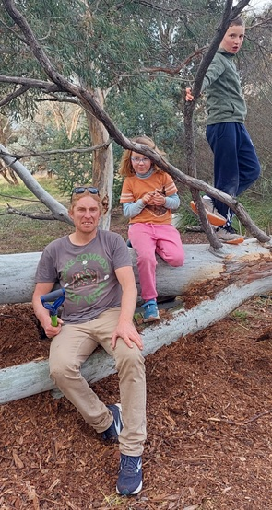
A
drian and Alycia enjoy their life at Phillip Island (connected by a bridge, a couple of hours from Melbourne). They seem to have most of what they need on or near the Isl., and minimise going into Melbs. AJ still manages the “Cape Community Farm”, working with volunteers, school groups and visitors. The enterprise produces fresh produce for sale, and performs an educational role in the community (See it in FaceBook).

Alycia works at New Haven College, and loves ocean swimming, bike riding and attending the extracurricular activities that come with life at a private school. Iona’s first violin concert was an impressive milestone!

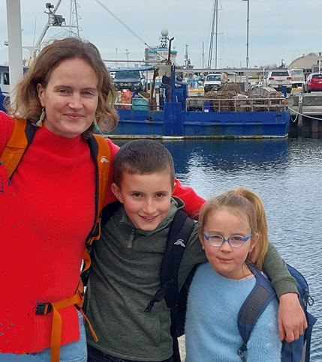
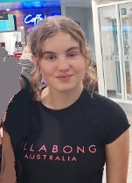
Jeanne and Robert travelled to Hobart for Jeanne’s teachers conference. We happened upon Alycia, Iona, Rohan and Lily, holidaying there at the same time. Alycia was visiting her sister who works at the University of Tasmania as a researcher, having recently completed her PhD. We checked out the amazing Art Gallery and Museum together and then the family headed to the very modern Aquatic Centre.

Iona (7) has finished First Grade, and enthusiastically into ballet, violin and family camping expeditions. She enjoys her grandparents at the Isl. And in Canberra.

Rohan (9) coming into Fourth Grade, loves hiking, camping, bush bike riding and violin performance. He loves creating art and Lego machines!

Lily (14) has completed her second year, now at a new High School. She loves Soccer and other physical pursuits, YouTube productions and is a prolific reader.

C
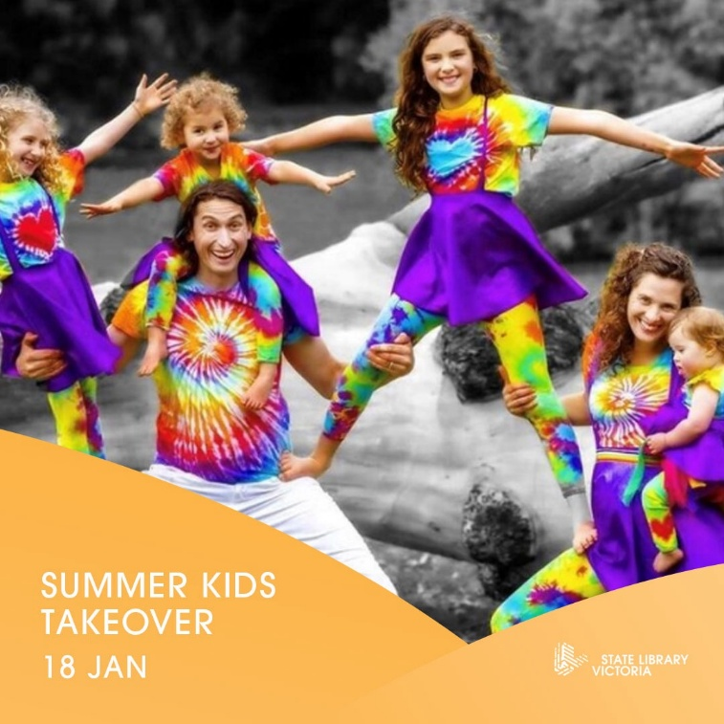
hris and Claire continue at quite a pace with their work in teaching, performance work and management of events. Their home at Millgrove is alive with the active family including dog Rosie, blue tongue lizard, rabbits and alpacas.

Chris has worked at various schools, current at Tintern College, now in their 145th year. Quite a pillar of the Melbourne edu establishment, and a far cry from the Montessori, Steiner and local public school environments of his prior experience. Chris loves festivals and creates extraordinary multi-function domes.

Claire Teaches circus, dancing and performance arts and manages the Dreaming Space business and the Funky Monkey Family Band, which features the whole family. The four children certainly started early and continue to be strongly oriented to circus and musical performance work.
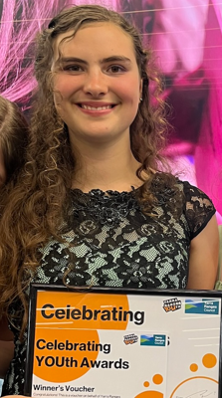
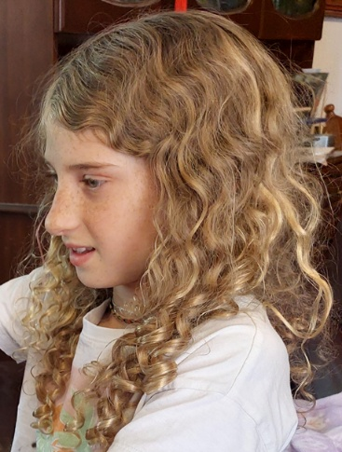
Eloura (14) has completed year 8 at the Little Yarra Steiner School, and indulges a passion for woodwork, drama, dance, art and anything festive. Her special project was to organise a Masquerade Ball – a complex undertaking that utilised and extended her many talents. This was a great success, and resulted in her winning the “Yarra Ranges Celebrating YOUth Award”. A well-deserved outcome!

Jasmin (11) is a dancer and circus performer extraordinaire. Enjoys crocheting, other crafts and playing violin. She does these activities at the Little Yarra Steiner School. Jasmin is a great assistance with her sister Indira. She does well in the “Funky Monkey Band” where she loves getting dressed up and performing with the family at festivals during the year and now around Christmas time she will be in her element.
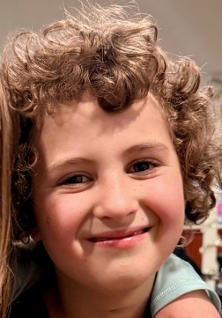
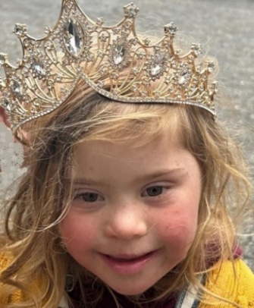
Orlando (8) is not only a key performer in the family band and circus, but also “the great constructor”, suffering from anxiety if he cannot make something each day. He has a well organised workshop where he feels he can construct something worthwhile and be proud of what he has made.! Orlando enjoys the “Litle Yarra Steiner” School very much and recently had a lovely birthday party where his friends came. Orlando also acquired a blue tongue lizard which he enjoys hanging out with it. The blue tongue lizard doesn’t feel scared and hasn’t attempted to scuttle off into the bushes.
Indira (6) is not yet “too big for her boots”, was enjoying life at the Tesselaars Tulip Festival and adds a lively note to any gathering. She has a penchant for attaching herself to random families at picnics etc, which can be interesting. Indira loves performing with the family at festivals and enjoys dressing up into a fancy new outfit for various occasions such as birthday parties.

K

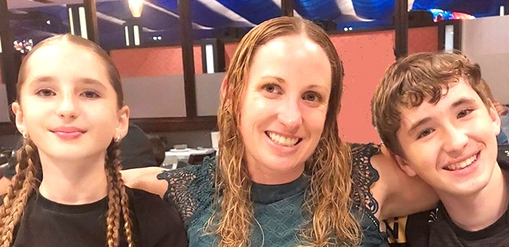
aren, Zoe and Jack seem to love life at the Central Coast, home of beaches, running tracks and sunshine! Nanna and Pa have been able to exchange occasional visits and keep track of developments. Karen has moved from her Gosford Hospital recruiting job to work for the Ministry of Health at St Leonards. This entails some train travel, but it’s only two or three days per week, plus working from home! Karen trail running, kick boxing and cycling seem to keep her pretty fit. So don’t tangle with her outside the Private Bin nightclub after closing time on a Saturday night!

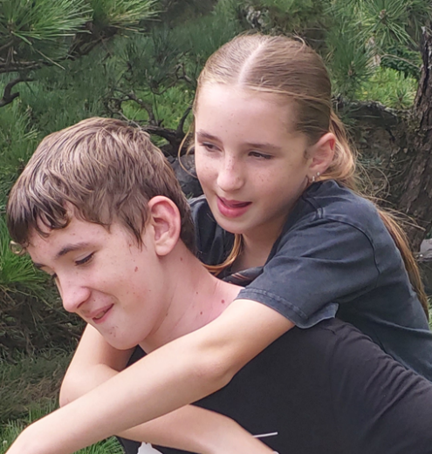
Karen Jack and Zoe popped-in to Canberra to catch-up with Nana and Pa and some Canberra “old buddies”. They flew off to Melbs to check on the Twelve Apostles and the cousins in Phillip Isl and Warburton. She had an amazing holiday with her brother’s families. The cousins enjoyed playing with each other as they are similar ages.

Zoe (turning 11 on 31 December, “going on 16”) has taken-up Oztag football with her girlfriends, enjoying the activity and the social aspect. Zoe has had a busy year of sleep overs, birthday parties and many outings. She is not averse to a little screen time, and enjoys communicating with her friends.
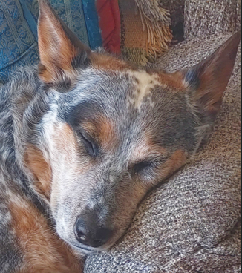
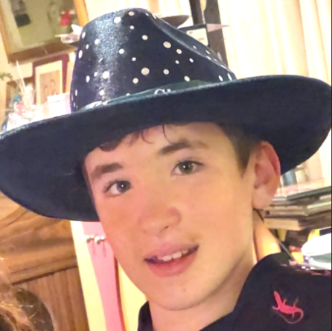
Zoe and Jack enjoyed a big trip to Queensland with Dad to visit Wade’s bro Uncle Glen. Wade is a great supporter of the family’s sporting activities.
Jack (13) is an impressive performer in Rugby League, Touch and Oztag football. He has eagerly embraced fishing, now as a sport at High School, and loves to do that with his friends. His social life has expanded to include sleep-overs with friends and birthday parties.

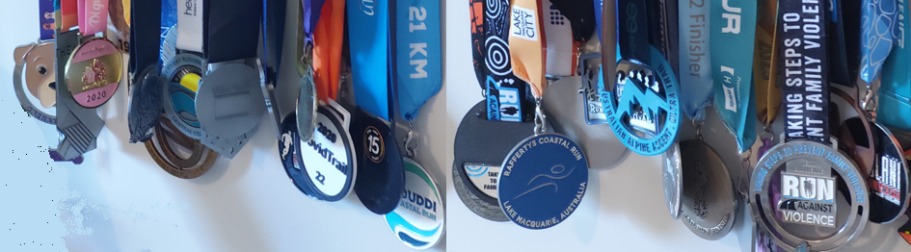
Patchy had a little holiday with Nana & Pa while the others were away. He plans to get off the lounge and take a walk after a little more rest.

Karen is exploring how to extend her house in order to display the increasing burden of running and kick-boxing medals!

J
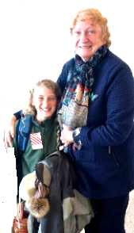
eanne and Robert have retained the old home at Watson, which continues as a Canberra base for various family holidays and gathering of cousins. Our life with Wesley Uniting Church entails multiple roles and has led to many friendships for 50 years now! This community of faith has been central to our family with its various connections and rites of passage.
As President of the Canberra Jung Society, Jeanne loves providing suppers, organising guest speakers and maintaining personal contacts. Our dual-format meetings “in person” and “on-line” provide social contact, music, library and suppers, and speakers by Zoom from their homes worldwide!

In the Canberra Interfaith Forum, we work with people of many faith traditions to stage public forums and promote interfaith trust and harmony. This was the fourteenth year of our Environment Meditation and Healing Garden at Grevillea Park with planting, watering, mowing, weeding and special events. We have maintained the Australian General Semantics Soc. with friends for more than 30 years, with seminars in in person and online, enabling our engagement with the GS Community “around the Globe”. We’ve had rather special engagements with the Royal Commonwealth Society, meeting extraordinary people sharing interests and concerns.

And would you believe, 2025 is our 50th Wedding Anniversary! Wed in 1975 in Yenda, survived crises and traumas, gave birth to three wonderful children and nine extraordinary g’children

Jeanne is still officially a relief teacher, but continually in demand due to an ongoing teacher shortage, particularly for “children with special needs”. She pursues her professional development via courses and conferences, this year in Hobart. Robert performs a vital role in minding the hotel key and attending Spouses’ social activities. Jeanne loves nature art activities, with studies in the Botanic Gardens and galleries, making up bundles of gifts for g’children, and baskets of treats for Halloween, and catering for church, Jung Soc and CIF events. Last month, we did lunch for 90 in the Legislative Assembly, for the Jung Soc’s 41st Anniversary.
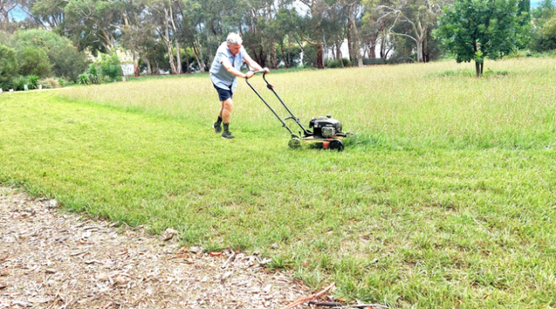

Robert shares interests and activities with Jeanne (as above), has interests in various Treasurer roles, Foreign Affairs, exploring science and engineering, Aust. Inst. of International Affairs, writes letters to The Canberra Times, argues with people, loves lawnmowing and planting trees.

(A plumper, link-infested version of this self-indulgent note is on our website)
Have a wonderful Christmas, a healthy and happy New Year 2026!
Namaste, from Jeanne and Robert James and our extended family.

