They said …

“The Institute promotes a scientific approach to understanding human behaviour, especially that related to symbol systems and language, and the application of proven principles that guide advancements in critical thinking, rational behaviour, and general sanity.”
Institute of General Semantics (IGS)

“How is it that humans have progressed so rapidly in science, mathematics, and engineering, yet we continue to exhibit behaviours that result in misunderstanding, suspicion, bigotry, hatred, and violence in our dealings with other people and with other cultures?”
Alfred Korzybski (Founder of GS)

“How we feel about ourselves, the joy we get from living, ultimately depends upon how the mind filters and interprets everyday experiences.”
Mihaly Czikzentmihalyi:

“Application of GS can help you to achieve ..
- More effective, discriminating dialogue with others, and with yourself,
- More favourable adjustments to uncertainty and challenge,
- A more tolerant, inquisitive, open-minded, “matter-of-fact” outlook,
- A greater moment-to-moment awareness of your own, and others’ perspectives.”
Steve Stockdale

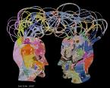

Australian General Semantics Society Inc.
Address
34 Buchanan Ave,
Bonnet Bay, NSW 2226
Telephone
(02) 9528 3296
Email
agssoc@hotmail.com
Web
www.ags.org.au
Meetup
www.meetup.com/Australian-General-Semantics/

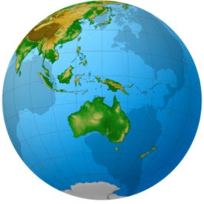

Institute of General Semantics
Address
3000 A Landers Street
Fort Worth, TX 76107 USA
Web
http://www.generalsemantics.org
Twitter
http://www.twitter.com/InstituteofGS
MySpace
http://www.myspace.com/generalsemantics
YouTube
http://www.youtube.com/InstituteofGS
Vimeo
http://www.vimeo.com/InstituteofGS

- Searching for better understanding?
- Interested in self-improvement?
- Concerned about clear thinking?
- Seeking to master critical thinking?
- Wondering why other people’s thinking seems so different to your own?
- Thinking the world could be so much better, that our situation could be improved?
- Anxious for your personal or professional life?
- Concerned with our human situation?
- Wanting to improve communication?
- Wanting to manage conflict better?
- Wanting to improve relationships?

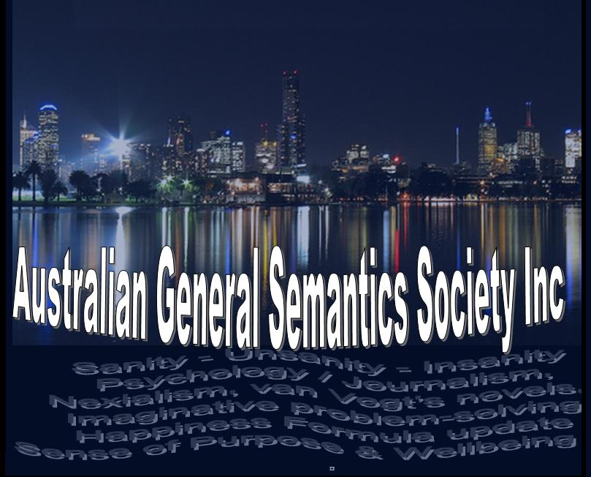
General Semantics (GS):-
- Includes the study of the structure of symbol systems (particularly language) and how it affects thought and actions.
- how we perceive, construct, evaluate and communicate our life experiences,
- a non-religious, non-ideological interdisciplinary system with practical applications for everyday living,
- a point of view that applies a scientific way of thinking to the challenges of everyday problem-solving,
- a teachable framework for critical thinking, media literacy and personal responsibility.

General Semantics arises from:-
- the work of Alfred Korzybski, a Polish engineer and military officer, and an extraordinary observer of human behaviour. He survived the horrific battlegrounds of World War I and wondered why humans could progress and advance in some areas, but not in others. He theorised that the attitudes and methodologies responsible for advancements in engineering, the sciences, and mathematics could be applied to the daily affairs of individuals and cultures. He called this new field General Semantics and introduced it as a practical, teachable system in his groundbreaking 1933 book, Science and Sanity. This work is a fundamental building block in diverse disciplines including RET and NLP.
- university courses, industrial and commercial training programmes, and ongoing academic research in USA, Europe, India, Australia and elsewhere.

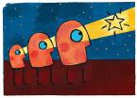
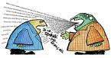

Some of the titles of books written about GS concepts give an idea of the scope of our discipline:

“Manhood of Humanity” (Korzybski)

“Science and Sanity” (Korzybski)

“Levels of Knowing and Existence” (Weinberg)

“Language in Thought and Action” (Hayakawa)

“Language in Human Affairs” (Lee)

“The Art of Creative Thinking” (Nierenberg)

“GS in Psychotherapy” (Caro et al)

“Tyranny of Words” (Chase)

“Self Management in Difficult Situations” (Cox)

“Explorations in Awareness” (Bois)

“Sensible Thinking for Turbulent
Times” (Levinson)

“Thinking Creatically” (Johnson)

“People in Quandaries” (Johnson)

“Drive Yourself Sane” (Kodish)

“Crazy Talk, Stupid Talk” (Postman)

“Language Habits in Human Affairs” (Lee)

“Sanity for Survival” (Pemberton)
Australian General Semantics Society (AGS)

AGS was founded over 20 years ago, by people interested in GS ideas and literature, who completed formal training overseas in the USA.

We meet in salubrious facilities at Bonnet Bay and elsewhere. We share resources, experiences and insights, and utilise the resources of our extensive library and the global GS community. It’s edifying and fun!

Some topics we’ve considered include …

“Science & Sanity” – The Foundation of GS
“Creative Intelligence and Self-Liberation”
“Cognitive Dissonance Theory & GS”
“The Non-identifying Personality”
“General Semantics in Buddhism”
“Meeting Challenge and Change”
“General Semantics in the Bible”
"Cause and Effect Formulations"
"Logical Fate and our Premises"
"Making Sense of Your World"
"Living Better - Living Longer"
“Skills for Effective Thinking”
"The Goldilocks Enigma”
"Man and his Symbols"
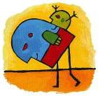
"The Art of Awareness”
”Enemies of Science”
"Letting go of Youth"
“Personal Insight”
"Beyond Truth”
“Time-Binding”
“Goal Setting”
Etc .. Etc ..!

