AKML 2019 – Symposium
Princeton Club, New York City.

“Changes in Free Speech, Hate Speech and Human Rights
in Australia – a GS Perspective”

Robert James 11/10/2019

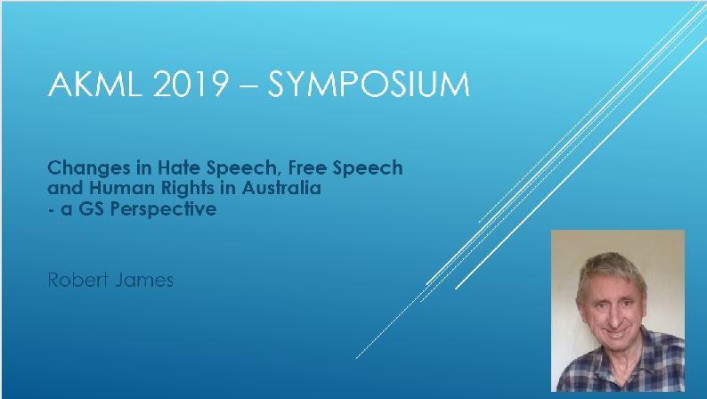

Hello, and greetings from the Australian General Semantics Society.
Great to be back, like home, for the AKML 2019 and Symposium!

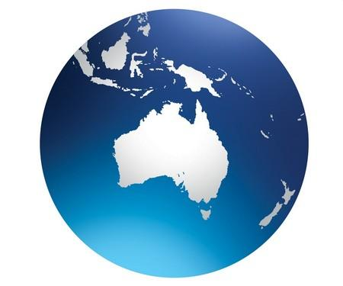

As you can see, we don't see Australia as the "land downunder"-
It's clearly at the centre of the world ...
Perhaps it's a matter of one's perspective!

I was here in 2012 when we had some excitement
when Hurricane Sandi visited New York.
But my lovely wife, Jeanne accepted Marty's assurances that it's not likely to happen again,
and I told her of the hospitality and kindness that I received here,
and how Kathy Levinson gave me maps and directions on how to get around!

So Jeanne came along to share my experience here,
and we've added some travels to Washington, Niagara Falls
and a tiny selection of the hurricane-free Big Apple.

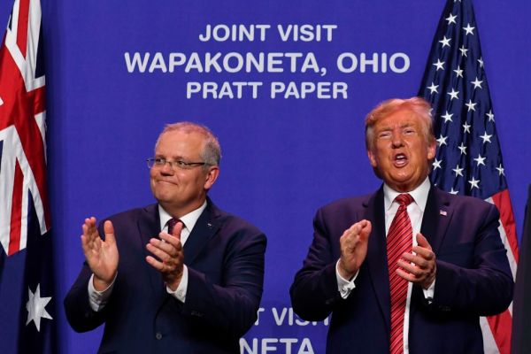

And we're not the only Aussies on the move -
It's just so heart-warming to see our Prime Minister
assisting your President with his election campaign in Ohio.

Through all this debate about free speech and hate speech and human rights,
I'm mindful of Alfred Korzybski's notion of time-binding,
which I believe underlies the whole framework of general semantics.

How much of what we say verbally or in other media
will be considered by our grand-children to be a valuable contribution to their world?
What will we be proud of, for them to build on and develop?

We're having a seminar in Sydney next month, to consider this challenge in more detail.
You're all invited - It will be our opportunity to return some of the hospitality that we've received here!

Well, we have been subjected to many and increasing impositions on our liberty,
which are mostly considered an acceptable time-binding cost of a civil society.

But the question "Are we free?" deserves more than an either/or response,
and this is where general semantics emphases the value of degree-orientation.

Most of us do not consider it an unreasonable imposition
to be required to drive on the same side of the road,
to refrain from attacking other people etc.

It's often said that
"Our freedom to swing our arms should extend as far as the other person's nose!".
That seems clear enough.

In Australia we do not have to carry or indeed, possess, any form of identification.
But for practical purposes, you need a bank account for wages etc,
a drivers’ licence for driving, and sometimes an identity for access to clubs etc.

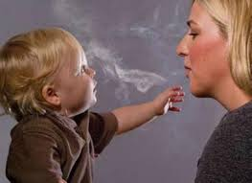

Smokers have been eased out of aeroplanes, restaurants,
office buildings, and now almost every covered public place,
in probably the most successful social engineering project in history.
Quite a restriction on freedom for smokers, but a significant health benefit for all.
Is this a case of projecting the risk caused by a single smoker, onto all smokers?

Australians have recently struggled
with the legalities of single-sex marriage (under Commonwealth law),
abortion, drug-reform, loss of the need to prove fault in divorce proceedings,
and voluntary assisted euthanasia.

In all these cases, the trend has been towards liberalising personal freedoms.

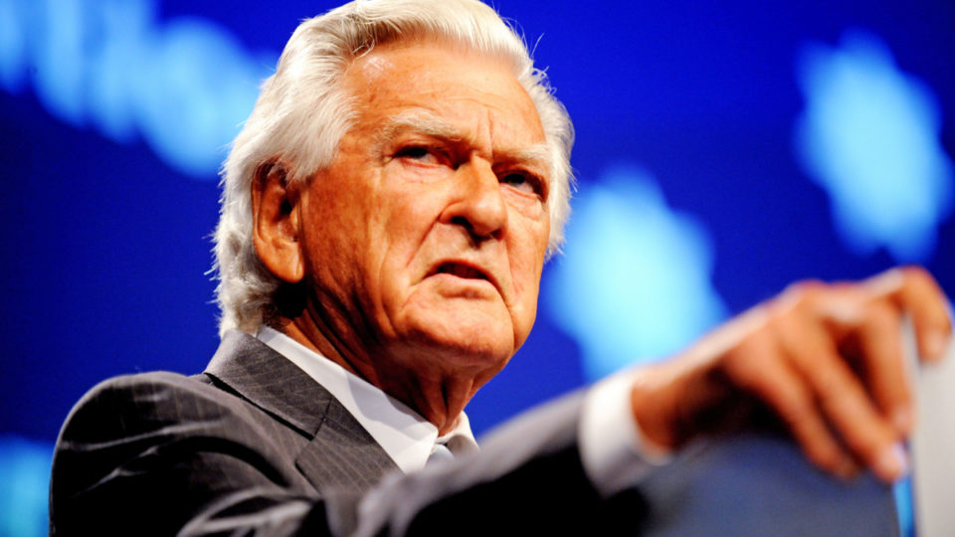

The word "bugger" used to be quite obscene.
Former Prime Minister Bob Hawk
was heckled when delivering a speech,
and retorted "Shuttup, you silly old bugger!".
The crowd loved it, Bob's popularity increased,
and the "b-word" became acceptable
to the extent that it started appearing in television advertisements.

So should we see the liberalisation of accepting rude language
as an increase in personal freedoms?

We general semanticists
love to apply dating and indexing,
to understand that these things change over time and space.
However some of us oldies might find this difficult.

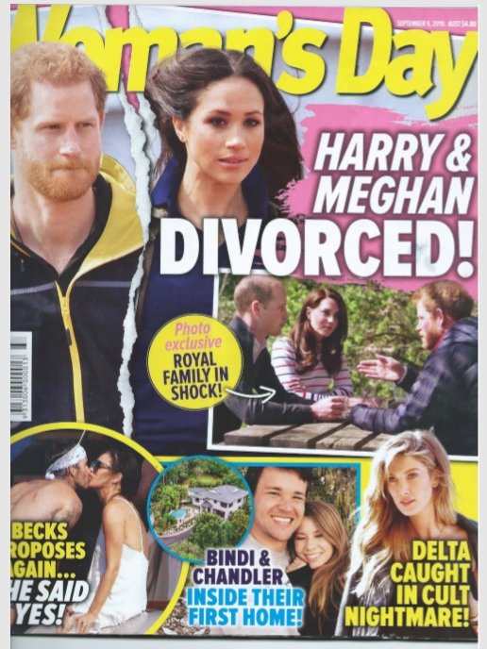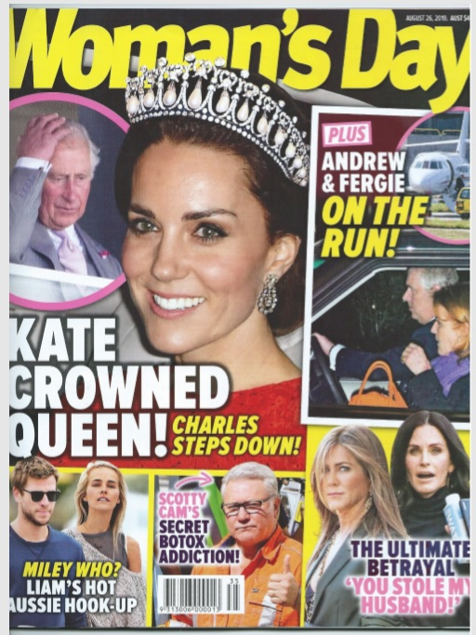

We are outraged by clear statements of falsehood
and fake news,
and suffer emotional damage
from the stress of careless or deliberate map-territory distortion,
but it's very difficult to claim damages at law on this account,
unless there's a clear financial consequence.
Simply publishing something that is factually false is not enough -
you have to prove damage to reputation or other financial consequence.

The USA Constitution first amendment does not distinguish between types of speech:
“Congress shall make no law respecting an establishment of religion,
or prohibiting the free exercise thereof; or abridging the freedom of speech, or of the press;
or the right of the people peaceably to assemble,
and to petition the government for a redress of grievances.”

Professor Nadine says that "the limit to free speech which I support
and which is supported by American law
is often paraphrased as the clear and present danger requirement."

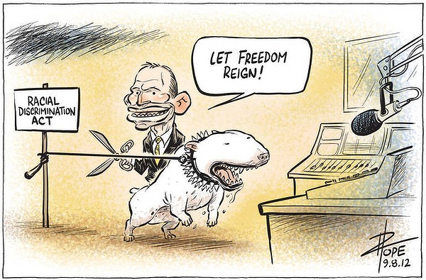

So, who can say what to whom?

In Australia,
the state laws have been harmonised under the Commonwealth Defamation Act 2005.
We no longer have separate laws for libel (written material) and slander (spoken);
it is all just defamation.

Basically nothing much has changed in recent times -
it's a question of establishing reputational damage on the basis of falsehood.
What's changed, of course, is the way that messages are communicated,
which certainly now includes email, online posts, books and published articles.
These laws are frequently invoked, resulting in the imposition of substantial damages.

Racial Discrimination
Section 18C of the Racial Discrimination Act
– Australia’s federal hate speech law –
has tended to dominate public debate about free speech for the last few years.
This has meant other important laws that restrict free speech in broad ways
are being overlooked.

There is no public interest disclosure exemption under this law.
So, even journalists reporting on activities
that a government might be undertaking illegally or corruptly can still be prohibited.
Security Concerns

The new laws relating to the Australian Security Intelligence Organisation (ASIO)
effectively gag all public protest against,
or even reporting of, the use of ASIO's new detention and interrogation powers.

It is now a crime, punishable by up to five years jail,
to publicly mention any operation involving ASIO's unprecedented powers
to detain and interrogate people without charge,
simply on the allegation that they may have information relating to terrorism.

The very fact that someone has been detained
cannot be talked about publicly for up to 28 days.
No other information about the detention can be disclosed for two years.

In effect, these measures outlaw political campaigns
against arbitrary or illegal detentions.
If someone sees a person being hauled away by ASIO
or the federal police for questioning,
they cannot disclose that fact to anyone -
not even a family member, friend, civil liberties group,
member of parliament or political party.

If a detainee's family or associates somehow find out about the detention,
they cannot publicly comment on it in any way.
Penalty: imprisonment for 5 years.

In a significant departure from established law,
the Act effectively reverses the burden of proof,
overturning a basic protection against police frame-up.
If ASIO alleges a person has information or material,
the onus is on the individual to prove otherwise.

“Witness K”

In 2004, the very new nation of East Timor
was engaged in negotiations with Australia
to divide-up the $50b underwater oil and gas reserves,
the "Greater Sunrise" field, that lies between Timor and Australia.

The Australian Secret Intelligence Service (ASIS) (like the CIA) agents
had been instructed to bug offices of the East Timor government
to reveal its negotiating tactics and the competing views of cabinet members.
The ASIS operation remained secret and the treaty was signed.

Australia’s actions would have been buried in perpetuity,
had it not been for one ASIS operative, known only as Witness K.

We cannot reveal his name, but I have obtained a photograph
which I can share with you here:

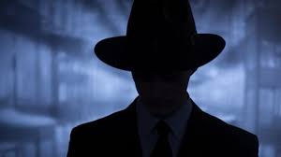

The senior intelligence officer felt deeply uncomfortable about the operation.
He obtained permission to talk to an approved lawyer, Bernard Collaery.

Collaery helped the East Timor government build a case against Australia
at the International Court of Justice in The Hague,
alleging that the bugging had rendered the treaty void.
(Incidentally, the United States has withdrawn from compulsory jurisdiction of the ICJ).

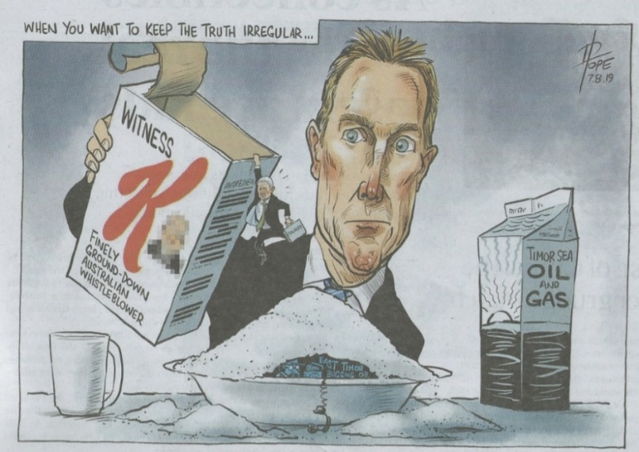

Another great opportunity for cartoonists with a serious message!

Witness K and Collaery now face jail time
for helping correct what they saw as a gross injustice.
Last month, Witness K pleaded guilty to sharing classified ASIS information -
a breach of section 39 of the Intelligence Services Act .
Collaery will fight on, facing a partially secret trial in the ACT Supreme Court,
the court where he has spent much of his life practising as a barrister.

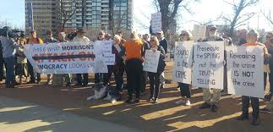

This is the subject of strong sentiments among caring citizens,

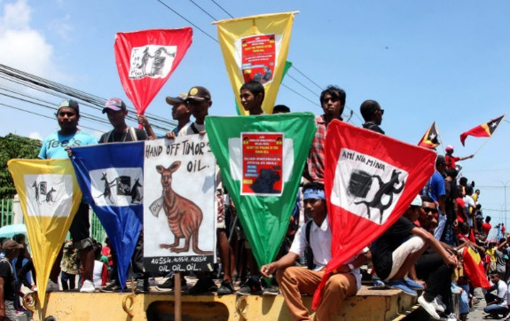

and energetic protests in Timor Leste.

Gavan McInnes Banned from Australia

One of the impediments of free speech is the banning of foreign visitors who espouse inflamatory views.

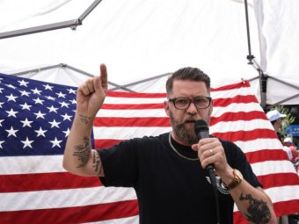

The Government cancelled the visa
of right-wing provocateur and founder of the Proud Boys group, Gavin McInnes
ahead of his plan to tour Australia with the group The Deplorables.

The explanation was:
"It's up to Immigration Minister to explain who he lets into Australia
and how his decisions meet community standards and expectations.
The Immigration Minister would not grant a visa
to anyone who intends to vilify a segment of the Australian community
or sow dangerous seeds of disunity."

"Allowing McInnes into our country
would have crossed red lines
and would have sent the message that it is open season on the Jewish community
and that vilifying and maligning Australian Jews is OK and normal," he said,

"I have no doubt that his visit would have cultivated a disruptive atmosphere
of incitement as well as attracting hardcore extremists,
and this explosive combination could have resulted in rioting and street fights,"
Dr Abramovich said.
"For visitors who may hold controversial views,
any risk they may pose
will be balanced against Australia's well-established freedom of speech
and freedom of beliefs".

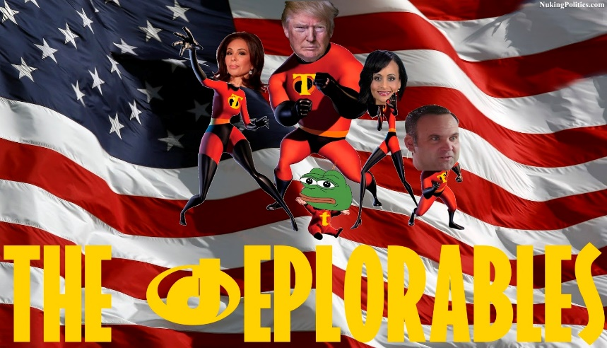

I note that the FBI lists The Deplorables group as 'extremist',
and Immigration officials deemed Gavin McInnes
had failed a "character test"
based on extreme views and a petition of 81,000 signatures.

The Proud Boys list their values as including being against political correctness,
racial guilt and racism, while promoting free speech and gun rights.
But they have been widely criticised
as promoting violence against people who do not share their views.

Religious Context

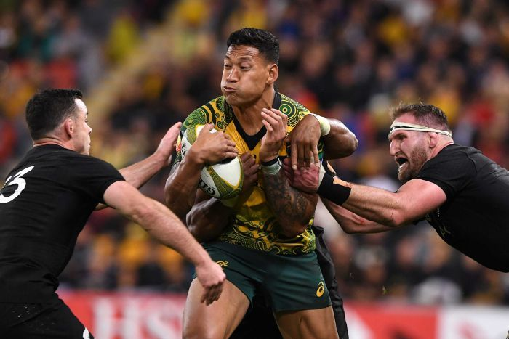

Some of our alleged threats are home-grown, of course.
Here is professional rugby union player and devout Christian, Israel Folau.
Quite a nice sensitive, new-age guy, as you see.

He made headlines when he was dismissed by Rugby Australia
for posting homophobic tweets from his personal account.
Folau is taking his former employers to the Fair Work Commission,
with his lawyers arguing that under Section 772 of the Fair Work Act,
it is unlawful to terminate employment on the basis on religion.

Rugby Australia maintains that his sacking is in line
with a high-level breach of the Professional Players’ Code of Conduct,
which strictly prohibits anti-gay social media posts.

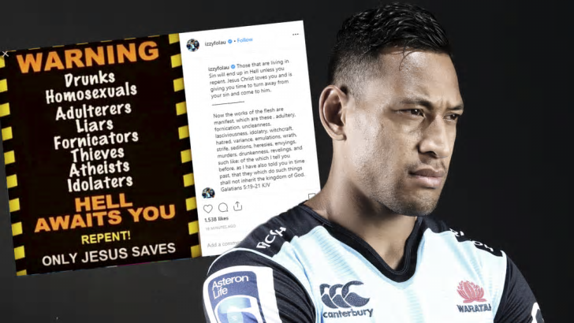

This controversial case has highlighted the conflict
between freedom of religion and freedom of speech in Australia,
and points to some systemic flaws
in Australia’s constitution to protect fundamental human rights.

The right to religious expression is detailed in section 116 of the Constitution -
this prohibits the Commonwealth from making any law
which prohibits the free exercise of any religion.
but this does not specifically support the right to free speech in a religious context.

The Racial Discrimination Act. Section 18C states that
“a person may not offend, insult, humiliate or intimidate another person in public
because of their race, colour or national or ethnic origin”,
however this does not protect against homophobic speech.

So in accordance to the law -
Folau was well within his right to express his religious beliefs,
despite their assault on members of the queer community.

The Israel Folau case is just one of many recently
which have pointed to holes in free speech laws.

Other Offensive Speech

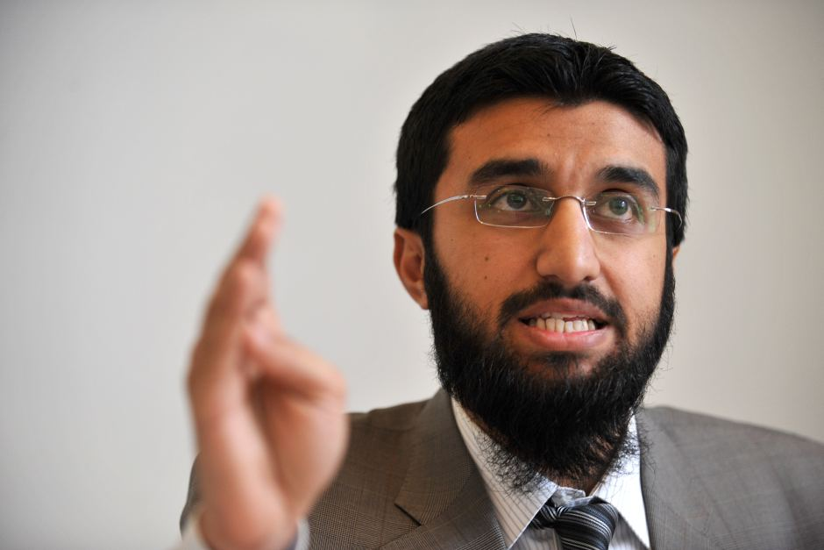

Sydney-based Muslim speaker Uthman Badar,
from Islamic group Hizb ut-Tahrir, was to give a speech,
titled 'Honour Killings Are Morally Justified'
at the Festival of Dangerous Ideas in 2014.
However, the event sparked such an enraged response
on social media and talkback radio, that it was eventually cancelled.

The state's Minister for Women,
and the Minister for Citizenship and Communities,
were both fiercely critical.
The Festival Curator said that the event had been withdrawn
due to the level of public anger.
"The justification for removing it was simply the level of public outrage," he said.
"We took the view that it was so strong and overwhelming
that the ability of the speaker to even open up the question
for some discussion and reflection would be impossible.

Shortly before his session was cancelled,
Mr Badar blamed anti-Muslim sentiment for fuelling the "hysteria".
"What's interesting is that I'm being attacked left, right and centre
without having opened my mouth yet.", he said.

Mr Badar said "What is different is that I'm Muslim -
one willing to intellectually challenge secular liberal ideology and mainstream values -
and that says a lot about the true extent of freedom and equality
in modern Western liberal democracies such as Australia."

Note that Hizb ut-Tahrir, for which Mr Badar is a spokesman,
advocates the establishment of a global caliphate - or Islamic state.

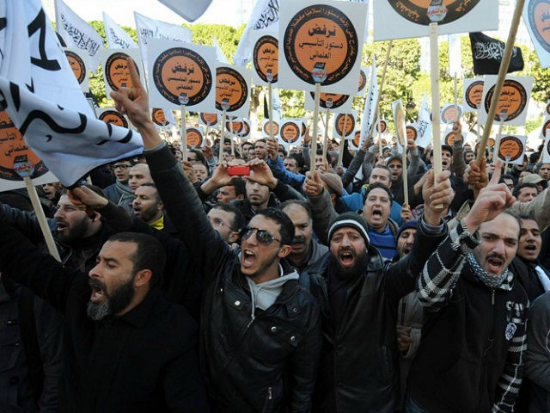

Again, we can see that there was a certain amount of community emotion regarding this case.

Note that Hizb ut-Tahrir (Party of Liberation)
is an international, pan-Islamist and fundamentalist political organisation.
The organisation is considered a radical Islamic group
advocating Sharia Law, including the provision that
"Those who are guilty of apostasy from Islam are to be executed".

Charlie Hebdo – Would have been Forbidden in Australia?

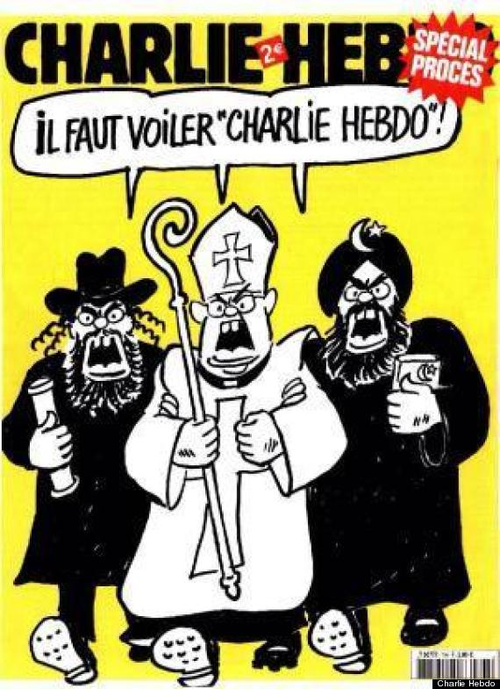

Charlie Hebdo ("arl bdo") is a French satirical weekly magazine
featuring cartoons, polemics and jokes.
It is irreverent and stridently non-conformist in tone,
publishing articles about the extreme right, Catholicism, Islam, Judaism, politics and culture.

Critics claim that its material
is deliberately provocative and insulting to many people's revered principles.
To that, cartoonists reply "Of course!".

In 2007 the Grand Mosque of Paris began criminal proceedings
against the chief-editor Val, under France's hate speech laws
for publicly abusing a group on the ground of their religion.
The lawsuit was limited to three specific cartoons,
including one depicting Muhammad carrying a bomb in his turban.
The court acquitted Val, finding that it was fundamentalists rather than Muslims,
who were being ridiculed in the cartoons.

The magazine has been the target of a number of attacks,
presumed to be in response to controversial Muhammad cartoons it published.
In the second of these attacks, 12 people were killed and 11 wounded.
During the attack,
the gunmen shouted "Allahu akbar" ("God is great") and "the Prophet is avenged".

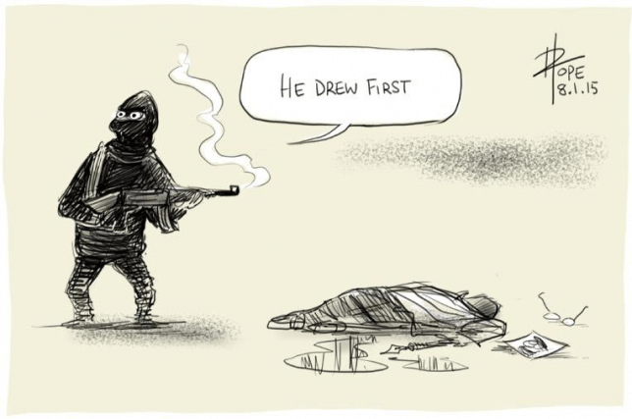

Our very-own David Pope of The Canberra Times
created this famous cartoon "He drew first", which captured the moment pretty well.
It is the job of cartoonists to critique and ridicule.
To make those in positions of pomposity and power feel uncomfortable.

There was a world-wide swelling of support for the "Je Suis Charlie" movement,
of people outraged by the dreadful attack.
But in fact, it's likely that the magazine would have been unable to publish
much of its vitriolic material in Australia, due to ant-religious hate legislation here.

So whereas nearly everyone I have checked with
would not particularly like the published contents of Charlie Hebdo,
and maybe thought that it should be banned in this country,
they deeply deplore the angry, violent response.

Causes for Optimism ?

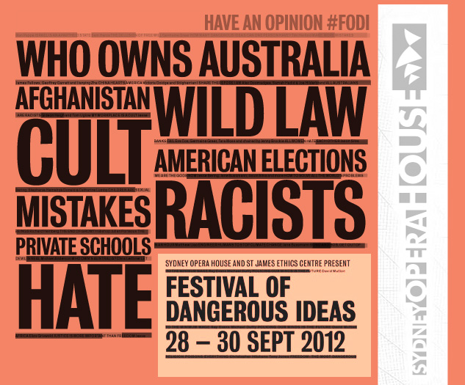

The Festival of Dangerous Ideas
(now known as ANTIDOTE)
has been presented by The Ethics Centre
and the University of New South Wales Centre for Ideas.

It aims to bring leading thinkers and dangerous culture creators
from around Australia and the world
to discuss and debate some of the most important issues of our time.

We have 40 or so speaker each year, including, for example,
Julian Assange of Wikileaks (sadly, not available to us at the moment),
Philip Nietzschke (advocate of assisted dying),
Germaine Greer (outrageous feminist),
Sir Salman Rushdie (of Satanic Verses),
Nadya Tolokonnikova (Pussy Riot in Moscow),
Peter Greste (imprisoned in Turkey for his journalism),
Tamika Mallory (Women's March on Washington)
and Micah White (Occupy Wall Street)

In 2018, it featured internet sub-cultures, fascism, privacy and LSD.

So here's Festival blasting out some "dangerous ideas" ...

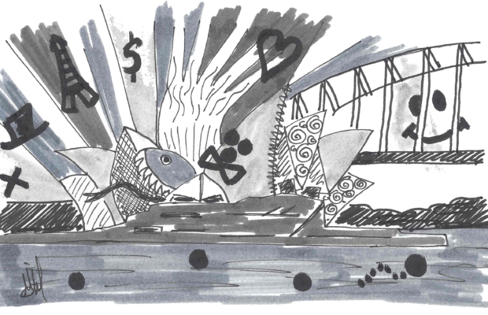

I'm rather jealous of the Ethics Centre and Uni of NSW for thinking of this -
it should have been a project of the Australian General Semantics Society!

Some GS Perspectives, and Conclusions

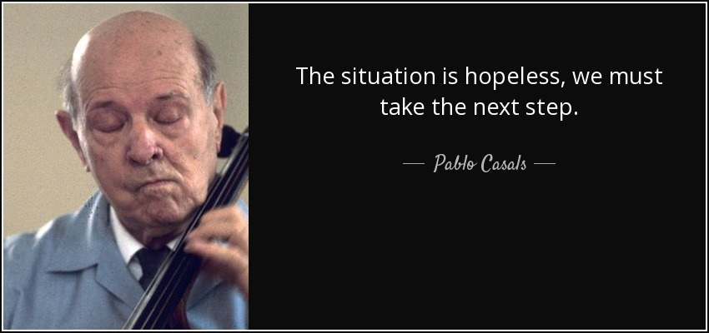

I recall Pablo Casals (winner of the Presidential Medal of Freedom 1963),
after complaining at length about the troubles of the world,
he paused to conclude with the observation:
"The situation is hopeless. We must take the next step".

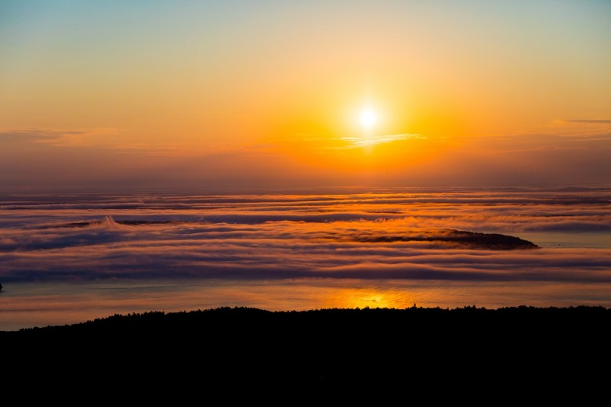

Well, I don't "consider that the situation to be hopeless"!
We'll continue to enjoy each day's sunrise
on the "object level" as per the Structural Differential,
to think globally and act locally as they say.

We can inspire and influence our family and friends,
create materials for future generations,
write letters to newspapers,
lobby policy-makers,
and work with our comrades internationally.

"Long live general semantics!"

~0~

